**Evaluation Title**

* Use full title of project
* Can be used for final evaluation, baseline, midterm, ex-post, or other types of studies.



**Evaluation Methodology**

* 200 words
* Purpose of the evaluation or other study
* Include who collected information, collection type (survey, focus group, literature review, other) and level at which information was collected (individual, household, village, etc.)
* This section is about the EVALUATION, not about the project.
* Any potential limitations to the methodology or execution of the evaluation/study that could affect the findings

**Photos**

* Provide 4-6 relevant photos to MCS; they will place and format based on space.

**Project Summary**

* 150 words
* Country(ies) and region/zone of project
* Funder
* Start/end date; date of evaluation
* Project goal
* Why LWR believes it’s important/relevant
* # beneficiaries (anticipated vs actual)

**Overview of Evaluation**

* Simple and direct
* 2-3 lines, 50 words

**Summary of Findings**

* 1000 words for whole section (i.e Pages 2 and 3, inside section)
* Sub-divide into 5-7 relevant sub-sections with headers, which will be different for each evaluation
* Each section should begin with 2-4 bulleted results and then have relevant content explaining how the results
* Strongly recommend to organize around key project objectives/outcomes where relevant

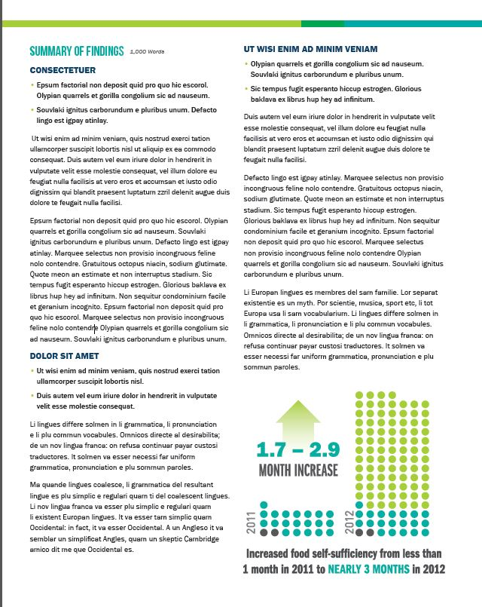

**Infographic or Chart**

* Use at least one infographic or chart to display numerical data
* MCS can design but project team must provide data/concept
* Should be directly tied to the section in which the infographic appears.



**2 Text Boxes**

* Call out one phrase or data point from evaluation
* Could also be a quote—use qualitative information to tell the story from the data.
* Text boxes can go anywhere in the document, and should be near the most relevant content

**Conclusion**

* Summarize the findings here; 2-3 paragraphs
* Ties it together, answers “so what?”

**Map**

* At least one map showing the project site(s), highlighting relevant regions as appropriate

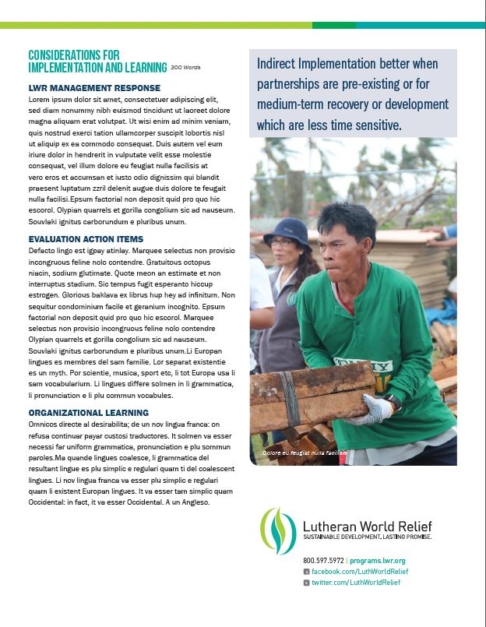

**Considerations for Implementation and Learning**

* 300 words
* Divide into the following subsections (approx. 1 para. each):
* **LWR Management Response**: Does LWR/LWR’s project team and partners agree with the findings? Disagree or validated and if disagree, what part and why? Do they believe the method was appropriate and evaluation carried out effectively? Any other comments?
* **Evaluation Action Items**: What will be specifically done in the short-term in this project area, as a result of the findings/recommendations?
* **Organizational Learning**: What are the ways LWR/partners will learn from this evaluation and how does it influence how we work and what we do?

**Easy Reference Table**

|  |  |  |  |  |  |
| --- | --- | --- | --- | --- | --- |
| **SECTION** | **Overview of Evaluation** | **Project Summary** | **Evaluation Methodology** | **Summary of Findings** | **Considerations for Implementation and Learning** |
| Purpose | Brief synopsis of the Evaluation | Paragraph of where the project is located (countries and/or districts/zones), who the funder is, what the dates are, what the project goal is and why LWR believes it’s important/relevant, how many anticipated beneficiaries. | Explains how the evaluation was conducted, by whom, when, and using what methods. | The main body of the document. Each sub-section should be on a different topic. The sub-sections begin with bullet points summarizing the main finding(s) for that topic. Ends with Conclusions about the Findings. | Explains what LWR is going to do with this information. |
| Word limit | <50 words | <150 words | <200 words | <1000 words | <300 words |
| Hints | * 2-3 Sentences | Regarding the PROJECT:   * Who * What * Where * When * Why * How Many? | Regarding the EVALUATION:   * Who * When, and if that timing is important (post-monsoon, post-harvest, etc.) * Which evaluation tools were used (survey, focus group, literature review, etc.) * Sample size, why was it chosen? | * Approx. 2 pages singled spaced * Sub-divide into 5-7 sections with sub headers. * Each sub-section should begin with 2-4 bullet points with main ideas and/or results. * Conclusions section at end has no bullets but summarizes the main themes briefly. | Divide into the following subsections:   * LWR Management Response * Evaluation Action Items * Organizational Learning |