

**Bulletin from the LWML Texas District - September 2024**

*For we are God’s handiwork, created in Christ Jesus to do good works, which God prepared in advance for us to do* (Ephesians 2:10 NIV).

**THANK YOU** for the outpouring of love in the form of quilts and kits at the Texas ingatherings in November 2023. Over 16,000 quilts, 9,400 school kits, 12,500 personal care kits, and 1,750 baby care kits were gathered at the three ingatherings in Texas and sent to the LWR warehouses. To God be the Glory!

**The 2024 Texas LWR ingathering schedule is on page 2.**

**KUDOS for Thinking Like a Bug** and for the most part doing a super job at packing and labeling the boxes but there is always room for improvement. It might be annoying to label each side, tape up each seam and make sure your label is attached correctly (on the side – not the top) but for the volunteers loading the trucks and for the LWR warehouse workers it is a huge relief. Each year the volunteers have had to re-tape, re-label and sometimes even re-pack to meet standards, so please pack your manageable-size boxes correctly. We appreciate it so much when boxes come in ready to load onto the trucks.

**MONETARY DONATIONS WILL NOT BE ACCEPTED AT THE INGATHERING SITES**. Any and all monetary donations need to be mailed **directly** to the Lutheran World Relief headquarters (see page 4).

Friendly reminder that LWR IS **NO LONGER ACCEPTING FLEECE BLANKETS** LWR has received information that fleece causes environmental concerns and therefore will NOT be collecting them.

And don’t forget LWR IS **NOT ACCEPTING BULK SOAP**. The Baby Care and Personal Care Kits still require soap. We are just not accepting any soap in separate boxes.

**PACKING QUILTS AND KITS:**

1. Use SMALLER AND STURDY BOXES, no more than 30 lbs. per box or smaller is better.
2. Pack only ONE TYPE OF ITEM OR KIT PER BOX and KEEP A TALLY OF ITEMS IN EACH BOX.
3. PACK BOXES TIGHTLY. Try sitting on the box to be sure it is tight. If it is “squishy” you may be asked to repack at the collection site.
4. TAPE ALL OPEN EDGES AND HOLES IN BOXES WITH MAILING TAPE, no masking tape. See “THINK LIKE A BUG” for more information (see page 3).
5. PLACE SHIPPING LABEL ON SIDE OF BOX AND TAPE OVER IT (see page 6).
6. LABEL ALL SIDES, TOP AND BOTTOM IN LARGE BLOCK LETTERS WITH LWR AND NUMBER AND TYPE OF ITEM. Example: LWR 5 BABY CARE.
7. If you COMBINE YOUR DONATIONS WITH OTHER CHURCHES, the site coordinator will need a copy of the LWR INGATHERING REPORT from **each** church (see page 5).
8. NOTE the Quilt & Kit Trackers is no longer in service.

**LWR WEBSITE INFORMATION:**

The LWR website, www.lwr.org, has information on the “Get Involved” tab for preparing and packing quilts and kits along with a listing of the items needed for each kit. The ingathering sites can be found on the LWR website: “Get Involved Tab” – “Quilts and Kits” – “Find an Ingathering”. Videos are available on the website also. To order a copy of the LWR Quilt and Kit Ministry guide, call 1-800-597-5972.

**Specific items that SHOULD NOT be included or used for quilts and kits are as follows**:

1. Any item with a religious symbol or message, or your group’s name. Let the Holy Spirit do the heavy lifting on this – we don’t want to cause any repercussions for the recipients of the quilts or kits.
2. Any item with a US flag, US patriotic or military symbols, references to the US armed forces or camouflage.
3. No plastic bags enclosing the quilts, kits, or any items in them.
4. Do not add to or take out any item listed.

**NOVEMBER 2024 LWR INGATHERING SITES**

|  |  |  |  |
| --- | --- | --- | --- |
|  | **Houston** | **Seguin** | **Dallas** |
| **Area Served** | Southeast portion of state, including SE-ELCA and other Synods | Del Rio, Kerrville, Austin, Victoria and points south including SW-ELCA and other Synods | Temple to Lufkin and points north and west, including N&NW-ELCA and other Synods |
| **Drop-off Dates** | Saturday  Nov 2, 2024 | Wednesday  Nov 6, 2024 | Saturday  Nov 9, 2024 |
| **Times** | 9:00am – 3:00pm | 9:00am – 2:00pm | 9:00am – 3:00pm |
| **Location** | Epiphany Lutheran Church | St. John Lutheran Church | Messiah Lutheran Church |
| **Address** | 14423 West Road, Houston, Texas  77041 | 600 S. Center Street,  Marion, Texas  78124 | 1801 W. Plano Pkwy,  Plano Texas  75075 |
| **Telephone Contact for drop-off day** | 832-492-2208 | 210-415-0365 | 214-564-6107 |
| **Site Coordinator** | Sandy Miller  832-492-2208  [miller4vs1@sbcglobal.net](mailto:miller4vs1@sbcglobal.net) | Debra Mattke  210-415-0365  [dmattke@tlu.edu](mailto:dmattke@tlu.edu) | Priscella Reid  214-564-6107  [reid.priscella@gmail.com](mailto:reid.priscella@gmail.com) |
| **Lead**  **Coordinator** | Mary Afsharirad  LWML Texas District Mission Service Chairman  214-226-0225 (call or text)  [missionservice@lwmltxdist.org](mailto:missionservice@lwmltxdist.org)  [mja.lwmltx@gmail.com](mailto:mja.lwmltx@gmail.com) | | |

**Have your LWR Ingathering Report complete when you arrive at the site (see page 5).**

Report any monetary donations that have been sent directly to LWR on the LWR Ingathering Report

But do not bring shipping cost donations to the ingathering – send directly to LWR.

See page 4 for suggested contributions for shipping cost.

*We give thanks to God always for all of you, constantly mentioning you in our prayers, remembering before our God and Father your work of faith and labor of love and steadfastness of hope in our Lord Jesus Christ.*

1 Thessalonians 1:2-3 (ESV)

**THINK LIKE A BUG**

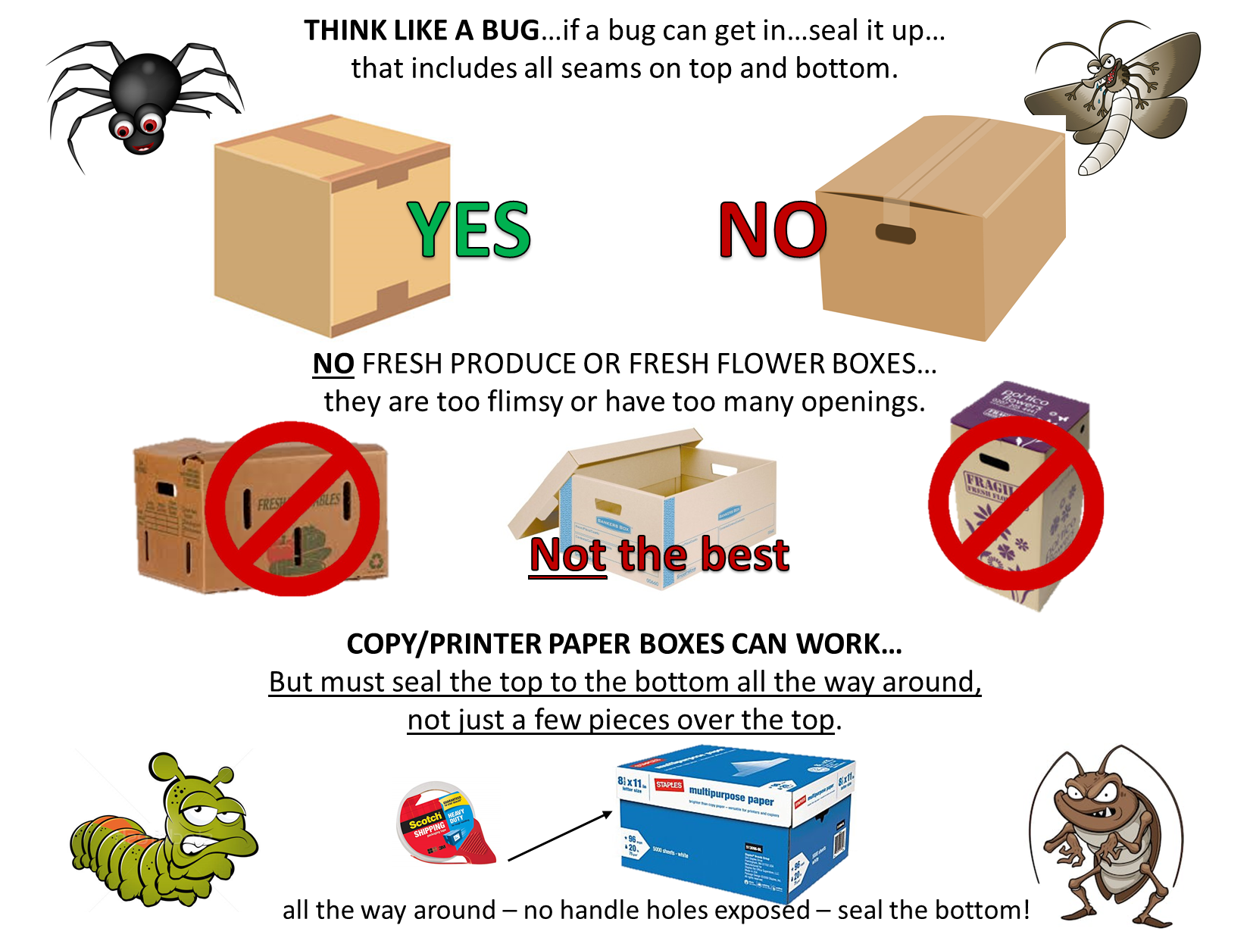

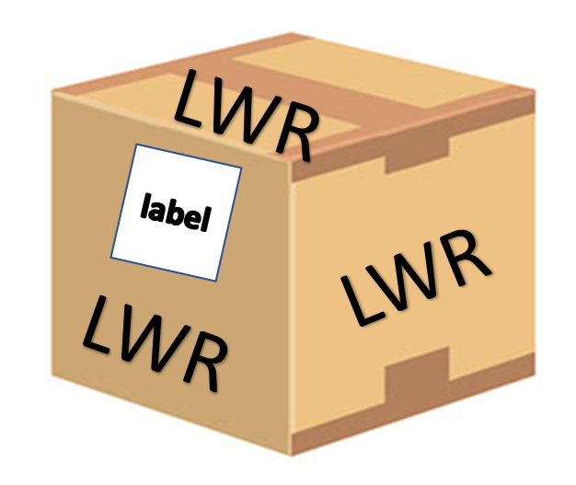

**HELPFUL HINTS**

* Best way to seal the box is the H-method on TOP and BOTTOM regardless of if the bottom is glued or not.
* No exposed seams or holes.
* Handle-holds seem like a good idea, but they are a NO-NO; seal over them.
* Fill to top of box so they won’t be crushed when stacked.
* No boxes should weigh over 30 pounds.
* The more uniform the shape and size of the boxes the better.
* **Tape down the label** and put it on one side of the box (not on top). See page 6 for labels**.**
* **Write LWR and number & type of item in large-block-black letters on the top, bottom and all four sides of the box.** Example: LWR 10 QUILTS
* Correct packaging and taping is the responsibility of the person bringing the boxes to the ingathering. Make sure they are packed correctly, or your delivery person may have to do triage.
* **Do it right, so no one must repack or add more tape.**
* Have your ingathering report ready to give to the site coordinator.
* Help us unload your boxes, please.
* Wait until your ingathering has been cleared for shipment before you drive off.

**Thanks for supporting**

**Lutheran World Relief**

* **Tape down the provided label and put it on one side of the box (not on top).**
* **Write** **LWR** in **large-block-black** letters on the top, bottom and all four sides of the box.
* Write on the top, bottom and all four sides of the box its contents (Ex. 10 quilts or 30 school kits, etc.)
* Bring your paperwork to the ingathering site.
* **Correct packaging and taping is the responsibility of the person bringing the boxes to the ingathering**.
* **Do it right**, so no one has to repack or add more tape.
* **Help us unload your boxes, please.**
* Wait until your ingathering has been cleared for shipment.

10 quilts

**THRIVENT ACTION TEAMS**

Thrivent Action Teams allow you to support the work of Lutheran World Relief while taking part in a meaningful service activity. Thrivent members are eligible to lead a service activity that can be completed within 90 days. Once you are approved to lead a team, Thrivent will send you a Thrivent Action Team Kit and a VISA card up to $250 for your volunteer activity. Go to *thrivent.com/actionteam* for more information.

**Lutheran World Relief**

**QUILT AND KIT** **SHIPPING COST**

updated 2024

LWR spends over $1.9 million to distribute about $18 million worth of quilts and kits each year. Encourage your contributors to collect monetary contributions to help distribute quilts and kits around the world.

**LWR's Approximate Cost to Deliver Quilts and Kits Overseas**

One Quilt or Blanket $2.80

One School Kit $2.85

One Personal Care Kit $1.50

One Baby Care Kit  $3.10

One Fabric Kit $1.80

Funds can be donated at <https://lwr.org/donate/shippingfund> or mailed directly to LWR.

**LUTHERAN WORLD RELIEF**

**QUILT & KIT SHIPPING FUND**

**PO BOX 17061**

**BALTIMORE, MD 21297-1061**

**Your generosity ensures LWR has the resources needed to move these items around the world.**

**DO NOT** send Quilt and Kit Shipping donations to the LWML Texas District Financial Secretary or

bring to the ingatherings.

**Lutheran World Relief Ingathering Report**

Date: __________________________

CONGREGATION NAME: _______________________________________________

Address: _____________________________________________________________

City, State, ZIP Code: ___________________________________________________

Contact Person: _______________________________________________________

Phone: ____________________________Email: _____________________________

**CIRCLE ONE:** ELCA ELDONA LCMC LCMS NALC

**LCMS Churches** – LWML Group Name: _____________________________________

|  |  |  |
| --- | --- | --- |
| **LWR ITEM** | **QUANTITY** | **# OF BOXES** |
| QUILTS |  |  |
| BLANKETS – **No Fleece** |  |  |
| SCHOOL KITS |  |  |
| PERSONAL CARE KITS |  |  |
| BABY CARE KITS |  |  |
| FABRIC KITS |  |  |
| QUILT & KIT SHIPPING FUND  **(Amount sent directly to LWR)** | $ |  |

**Please complete this form and bring with you to drop-off site. You may also wish to keep a copy for your records.**

**Church:**

**________________________________**

**________________________________**

**Address:**

**________________________________**

**________________________________**

**________________________________**

**Contents:**

**________________________________**

**Number enclosed: ________________**

**TO:**

**LUTHERAN WORLD RELIEF**

**601 MAIN STREET**

**NEW WINDSOR, MD 21776**

**Church:**

**________________________________**

**________________________________**

**Address:**

**________________________________**

**________________________________**

**________________________________**

**Contents:**

**________________________________**

**Number enclosed: ________________**

**TO:**

**LUTHERAN WORLD RELIEF**

**601 MAIN STREET**

**NEW WINDSOR, MD 21776**

**Church:**

**________________________________**

**________________________________**

**Address:**

**________________________________**

**________________________________**

**________________________________**

**Contents:**

**________________________________**

**Number enclosed: ________________**

**TO:**

**LUTHERAN WORLD RELIEF**

**601 MAIN STREET**

**NEW WINDSOR, MD 21776**

**Church:**

**________________________________**

**________________________________**

**Address:**

**________________________________**

**________________________________**

**________________________________**

**Contents:**

**________________________________**

**Number enclosed: ________________**

**TO:**

**LUTHERAN WORLD RELIEF**

**601 MAIN STREET**

**NEW WINDSOR, MD 21776**