
Congregational Update
Spring 2023
Addressing the root causes
of migration

Dear Partner in Ministry,
Thank you for your congregation’s partnership with Lutheran World Relief. Your love is making a powerful difference, traveling the distance to reach our neighbors in need, no matter where they are in the world.
This document includes updates for you to share with your congregation in a variety of ways: newsletter article, bulletin announcement, social media kit and video. It is formatted so that you, your staff or volunteers can copy and paste the text directly into your congregation’s publications.
To share the photos that accompany this update, please use the link on the bottom of page 5 to access and download the images. Please do not copy the photos directly from this document.
Thank you for sharing this story with your congregation about the ways your far-reaching generosity travels to our neighbors in the most distant corners of the world. We are deeply grateful for your partnership.
Please contact me if I can be of any assistance.



Rev. Lisa Kipp
Director of Congregational Engagement
congregations@lwr.org

Our congregation is empowering women and keeping families together through Lutheran World Relief

NEWSLETTER UPDATE
Copy/paste this text into your congregation’s newsletter

As Roselvina De León González prepares a nutritious meal for her family with produce from her garden, she beams with pride as she holds up the star of the show: a meaty oyster mushroom she grew in the greenhouse she co-owns with her brother Oribel. Joy made possible by the generosity of caring congregations like yours.

Oribel and Roselvina have learned to cultivate these mushrooms near their home in the Cantón Pin Pin community in Tacaná, Guatemala. The siblings have improved their own and their families’ health by adding the mushrooms — which contain fiber, protein and a variety of vitamins and minerals — to their diets, and they have also begun earning an income by selling them to their neighbors.

“We have learned how to feed our families, how to feed our children,” says Rosaura Sunun Gomez, an agricultural developer and local Lutheran World Relief partner. Rosaura receives training in nutrition and agricultural practices, then shares the information with community members like Roselvina and Oribel, who in turn share it with their neighbors.

Your generosity not only enables families to avoid traveling to markets to buy their food, but it also helps them stay in their communities rather than migrate to seek work.
Roselvina and Oribel’s sister tried twice to immigrate to the US because of lack of economic opportunities locally, but she was turned away. Roselvina sees every day how opportunities like oyster mushroom farming are changing the lives of people like her sister, who has since returned home. “To no longer think about migrating is the goal,” says Roselvina.

Our congregation’s love can help empower more women and keep families and communities together.

By supporting Lutheran World Relief, we are helping women like Roselvina and Rosaura to gain independence and marketable skills in a community where agriculture was traditionally considered men’s work. “We have learned that we also can get things done as women,” Rosaura notes. Instead of leaving their homes and families in search of a better life, they now have the hope, confidence and skills to grow a better life in their own backyards. To learn more, visit lwr.org or [insert specific congregational information here].

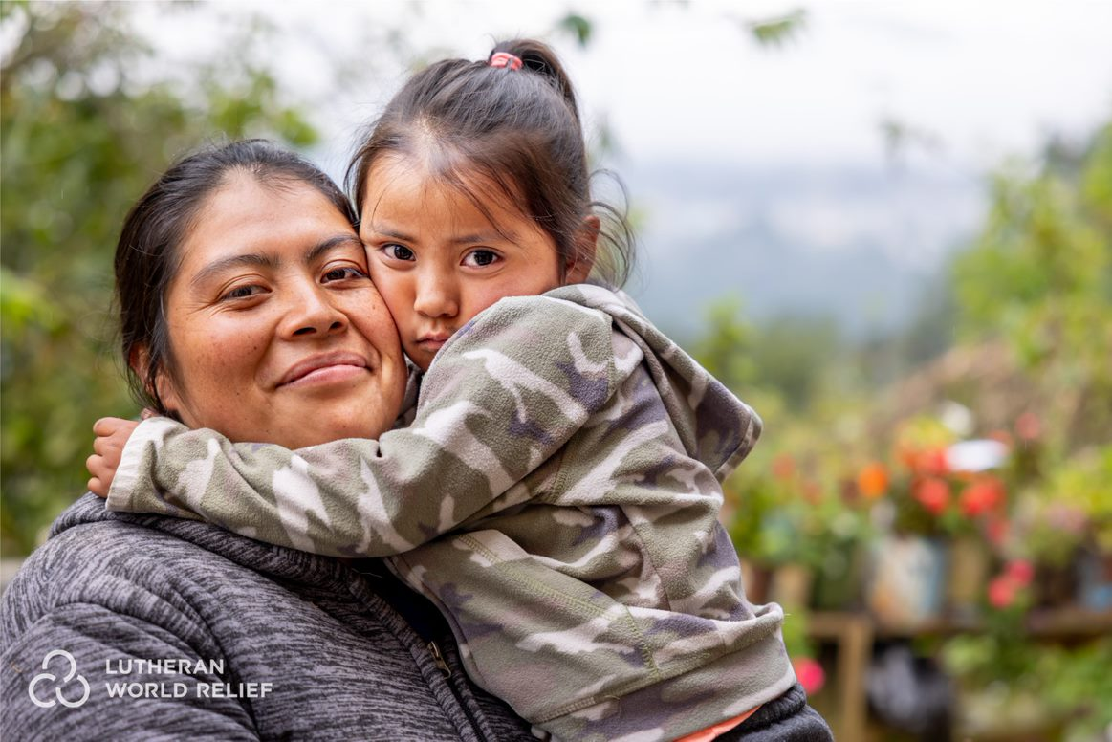
Roselvina De León González used to struggle to feed and provide for her family, including her four-year-old daughter Katherine. In the region of Guatemala where they live, it is common for young adults to migrate to other countries in search of work or a last-ditch effort to start over. Congregations are helping neighbors like Roselvina learn essential skills to grow nourishing crops to eat and sell – enabling families to stay together and find hope at home.

Our congregation is empowering women and keeping families together through Lutheran World Relief

BULLETIN UPDATE
Copy/paste this text into your congregation’s bulletin

So many families around the world are losing hope as they struggle to feed their families and make ends meet. Their last resort is migrating in search of work or a chance to start over. Our congregation is stepping up to help these families stay together and find hope in their own backyards. By supporting Lutheran World Relief, we are empowering women with marketable skills in farming and business so they can grow nutritious foods to eat and sell without having to migrate. Will you join us in helping families thrive together at home? To learn more, visit lwr.org or [insert specific congregational information here].


Share this social media update on your congregation’s Facebook page. The photos included can all be downloaded at the link below. Please do not copy the photos directly from this document.
SOCIAL MEDIA UPDATE
Copy/paste this text into your congregation’s Facebook page

To share this update:
- Download the images below using this link. Please do not copy and save the photos directly from this document.
- Create a new post on your congregation’s Facebook page.
- Copy and paste the bold text below into the status message.
- Add the photos you downloaded to your post.
- Hover over the photos with your mouse and click on Edit All. Copy and paste the photo descriptions (below, to right of photos) in each photo caption box.
- Click on Done.
- Click on Post.

Our congregation is empowering women and keeping families together through Lutheran World Relief.

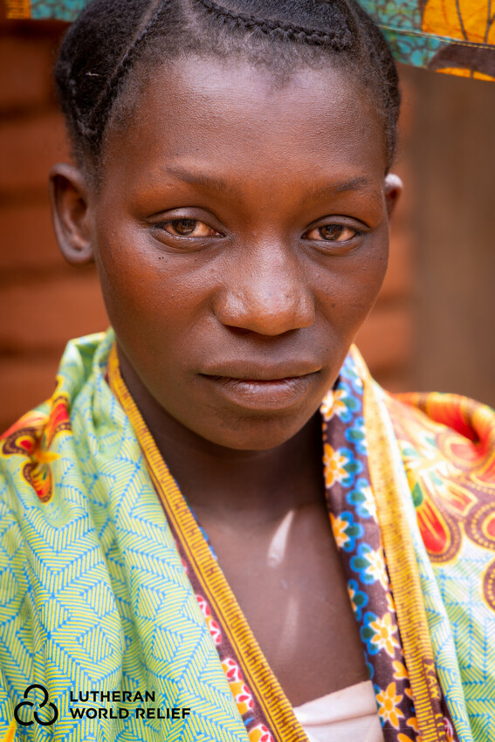
Roselvina De León González struggled to feed her family, including her four-year-old daughter Katherine, due to lack of economic opportunities where they live in the Cantón Pin Pin community in Tacaná, Guatemala.

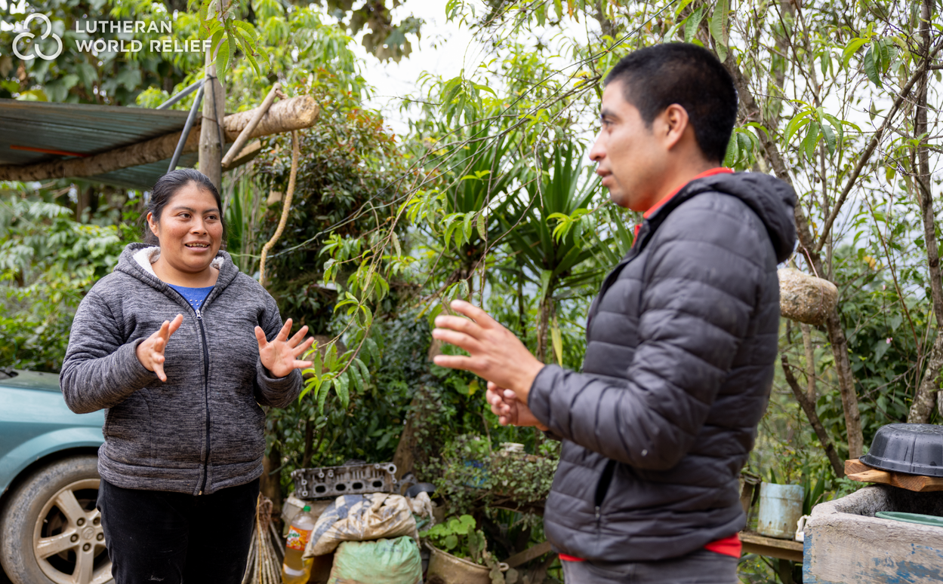
Often, young adults like Roselvina and her brother Oribel De León González (right) will migrate for economic opportunities when they can no longer find adequate work locally. Twice, their sister has made the long and dangerous journey to immigrate to the US only to be turned away.

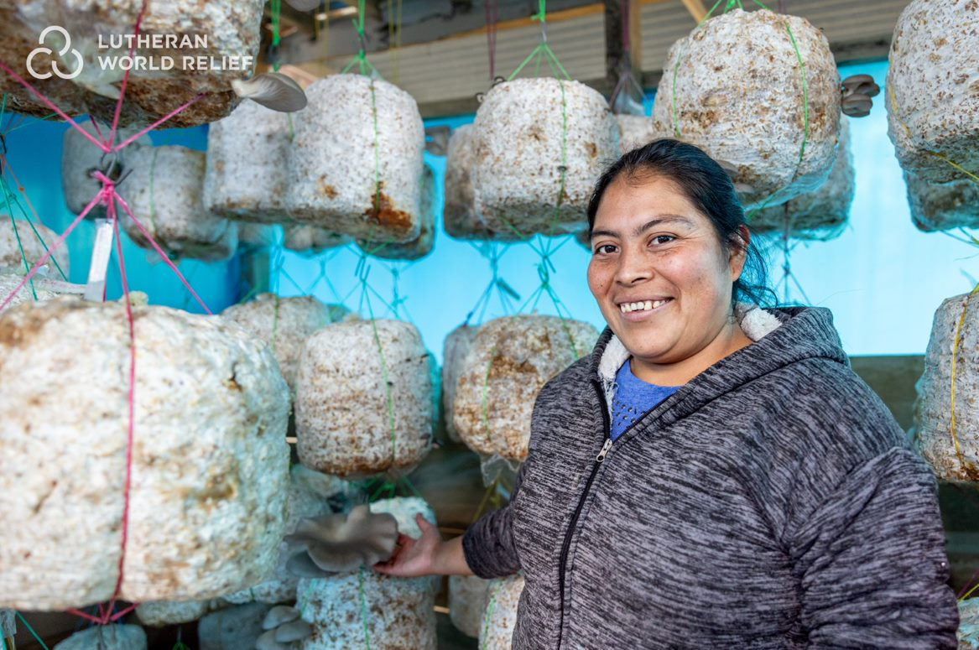
Congregations like ours are loving these neighbors by helping them to develop new agricultural skills to grow nutritious crops in their own backyards – supporting their family’s health and providing a source of income. Through Lutheran World Relief, we helped Roselvina and her brother Oribel set up an oyster mushroom greenhouse module on their family’s land. Oyster mushrooms contain fiber, protein and a variety of vitamins and minerals and are popular at the market.

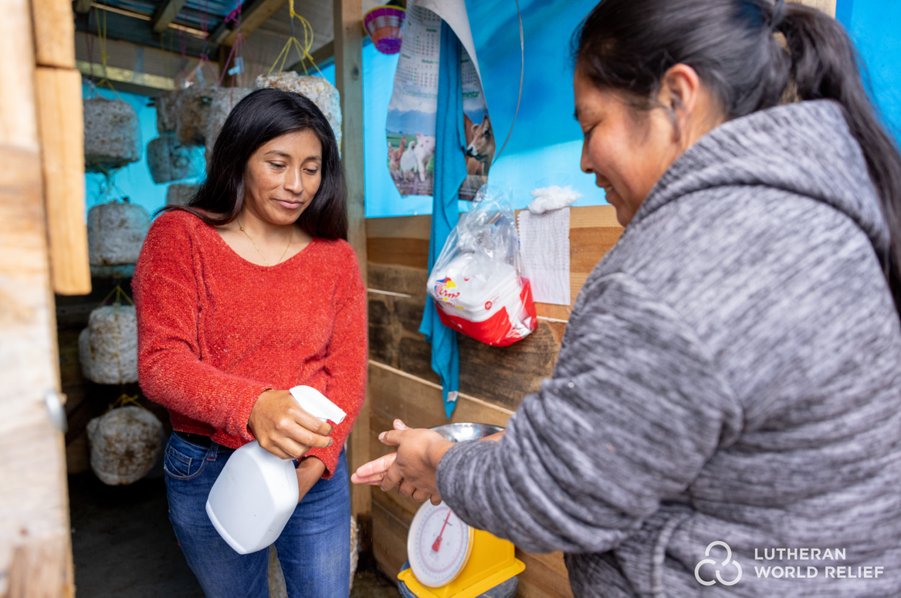
Rosaura Sunun Gómez (left) is an agricultural developer and local Lutheran World Relief partner. Rosaura receives training in agricultural practices and dietary needs, then shares the information with local community members like Roselvina and Oribel, who in turn share it with their neighbors. Here, she and Roselvina clean their hands before entering Roselvina’s oyster mushroom greenhouse.

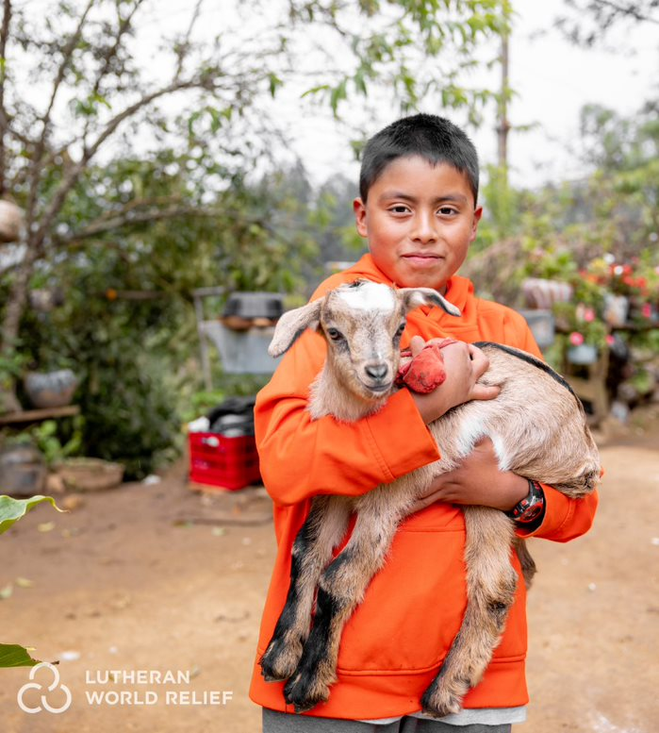
Now that their farm is bringing in enough income, Roselvina and her family no longer have to think about migrating. Instead, they are focused on continuing to expand their farm. Here, her son Manolo Ramirez holds Ernesto, the family’s baby goat. Thank you for helping to restore hope so that families can stay together and thrive at home.

TO DOWNLOAD AND SHARE THESE PHOTOS, VISIT:
https://photos.lwr.org/?c=3843&k=d080314b27

VIDEO TO SHARE
Share this video in worship or on your congregation’s Facebook page



Please share this thank you video with your congregation in worship or online.

View and share video on YouTube: https://www.youtube.com/watch?v=e0L3_O_AkN4

Download and share video: https://photos.lwr.org/?r=43288&k=bd255d6111

