
Congregational Update
Winter 2023
Special Thank You: Ukraine

Dear Partner in Ministry,
Thank you for your congregation’s partnership with Lutheran World Relief. Your love is making a powerful difference, traveling the distance to reach our neighbors in need, no matter where they are in the world.
This document includes updates for you to share with your congregation in a variety of ways: newsletter article, bulletin announcement, social media kit and video. It is formatted so that you, your staff or volunteers can copy and paste the text directly into your congregation’s publications.
To share the photos that accompany this update, please use the link on the bottom of page 5 to access and download the images. Please do not copy the photos directly from this document.
Thank you for sharing this story with your congregation about the ways your far-reaching generosity travels to our neighbors in the most distant corners of the world. We are deeply grateful for your partnership.
Please contact me if I can be of any assistance.



Rev. Lisa Kipp
Director of Congregational Engagement
congregations@lwr.org

Our congregation is traveling the distance and through Lutheran World Relief, helping desperate mothers a world away

NEWSLETTER UPDATE
Copy/paste this text into your congregation’s newsletter

Agata Nicolaus Mtewele is a mother of six in a rural area of Tanzania, hours from any roads, schools or medical facilities. She spends her days caring for her children — a 6-year-old son, 4-year-old twin daughters, and year-old triplets — and keeping up the house. When asked about her hopes for her children, she looks down to the floor with a sullen face. She can’t speak to hopes and dreams, only regrets.

“I try my best to do what I can, but I can see them not growing well.”

Agata lives with her husband Oscar Raymond on a small farm, their only source of income and food, although occasionally her neighbors will give her pumpkin or sunflower seeds. Without the help of her neighbors, Agata doesn’t get enough nutrition to breastfeed.

As a mother, Agata worries all the time. Her children are hungry, and she can’t afford soap, so the children often wear dirty clothes. Her husband is exhausted from farming, which has been less and less fruitful, leaving for the fields at 6 am and often not returning until evening, so Agata often finds herself alone in the child-rearing and housework.

The needs of her family overwhelm Agata — school fees, food, soap, clothing, there’s always something — but she enjoys being a mom, and lives for the rare moments here children are all together in one place, laughing and happy.

Our congregation can help
Agata, like so many mothers around the world, is broken and desperate, filled with helplessness at being unable to provide for her family. Our congregation is stepping up to help ease her hurt, closing the distance between her heartbreak and our help. By supporting Lutheran World Relief, we are improving the lives of mothers in poverty like Agata and providing the resources to make them more resilient and self-supporting, so the future of their families looks brighter. To learn more, visit lwr.org or [insert specific congregational information here].

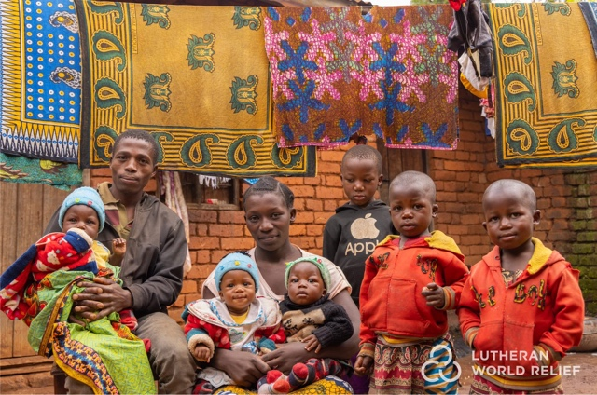
Agata Nicolaus Mtewele lives with her six children and husband in rural Tanzania. As a mother, she worries all the time. There is never enough and she knows her children aren’t growing well. Her husband Oscar’s crops aren’t doing well and there is little food, leaving her family malnourished and hungry. Medical care for her pregnancies was expensive, leaving them in even more dire straits. She is heartbroken, desperate to see her children grow up healthy, but feels there is little she can do.

Our congregation is traveling the distance and through Lutheran World Relief, helping desperate mothers a world away

BULLETIN UPDATE
Copy/paste this text into your congregation’s bulletin
So many mothers around the world are broken and desperate, filled with helplessness at being unable to provide for their families. Our congregation is stepping up to help ease their hurt, closing the distance between their heartbreak and our help. By supporting Lutheran World Relief, we are improving the lives of mothers in poverty and providing the resources to make them more resilient and self-supporting, so the future of their families looks brighter. Will you help us in bringing our love to mothers in need, no matter the distance? To learn more, visit lwr.org or [insert specific congregational information here].


Share this social media update on your congregation’s Facebook page. The photos included can all be downloaded at the link below. Please do not copy the photos directly from this document.
SOCIAL MEDIA UPDATE
Copy/paste this text into your congregation’s Facebook page

To share this update:
- Download the images below using this link. Please do not copy and save the photos directly from this document.
- Create a new post on your congregation’s Facebook page.
- Copy and paste the bold text below into the status message.
- Add the photos you downloaded to your post.
- Hover over the photos with your mouse and click on Edit All. Copy and paste the photo descriptions (below, to right of photos) in each photo caption box.
- Click on Done.
- Click on Post.

Our congregation is traveling the distance and through Lutheran World Relief, helping desperate mothers a world away.

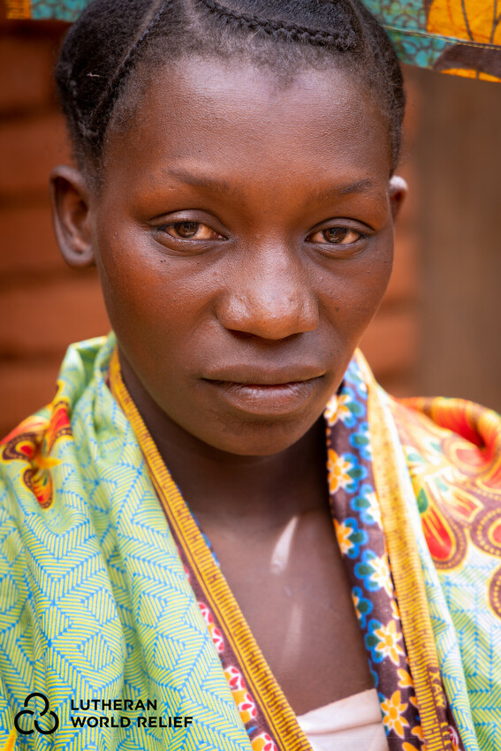
Agata Nicolaus Mtewele is a mother of six in a rural area of Tanzania, hours from any roads, schools or medical facilities. She spends her days caring for her children — and keeping up the house. When asked about her hopes for her children, she looks down to the floor with a sullen face. She can’t speak to hopes and dreams, only regrets. “I try my best to do what I can, but I can see them not growing well.”

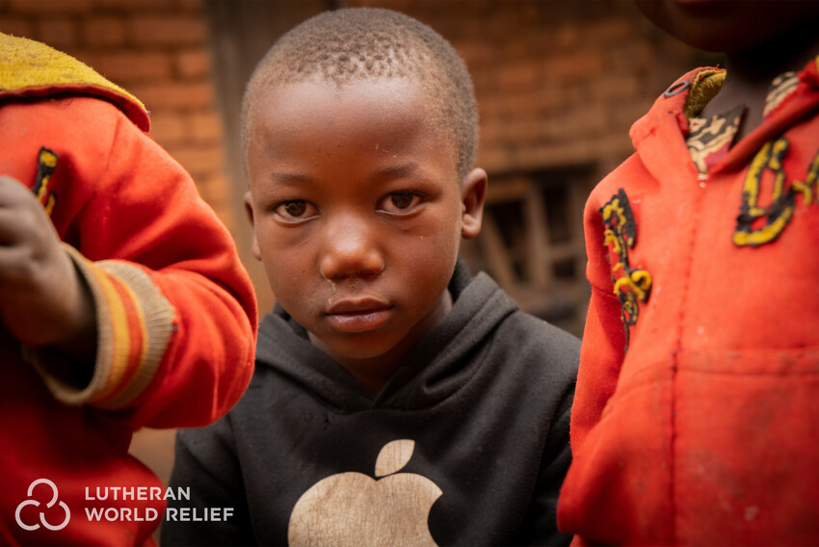
Agata’s son Evans, 6, tries to be helpful to his mother. He says his dream to “grow big to help Mommy.” He attends primary school, leaving the house at 5 a.m. for the two-hour walk each way and returning around 4 p.m. Compared to a six-year-old in the US, Evans is very small. But with more than 50% of the children stunted in Tanzania, he looks to be a “normal” sized first grader in Tanzania.

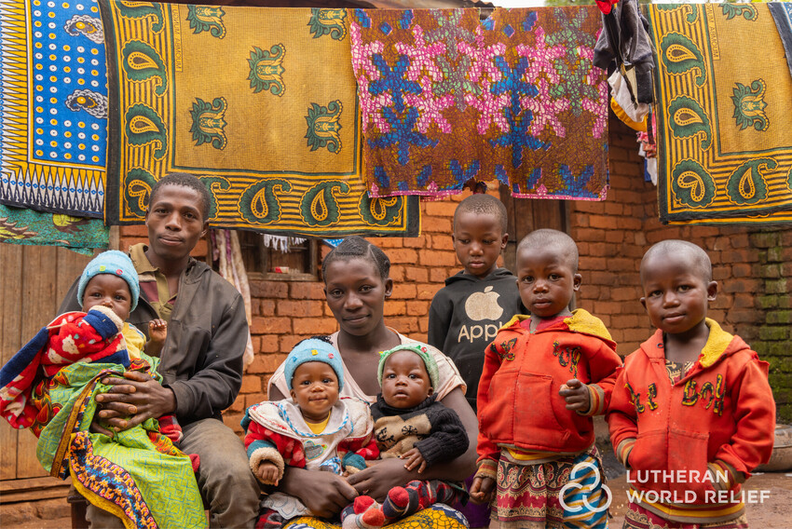
As a mother, Agata worries all the time. Her children are hungry, and she can’t afford soap, so the children often wear dirty clothes. Her husband is exhausted from farming, leaving for the fields at 6 a.m. and often not returning until evening, so Agata often finds herself alone in the child-rearing and housework.

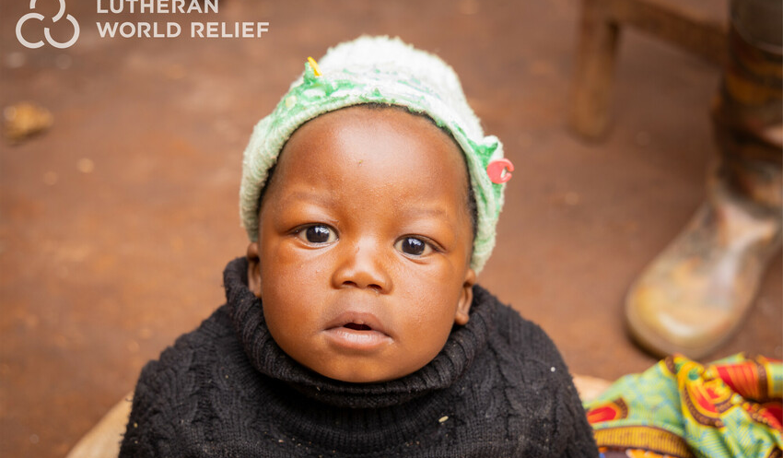
The delivery of Agata’s triplets came with the extra expense of a C-section. To prepare, they sold more of their food than usual to make ends meet. They ran out of the food they set aside, but neighbors have come together to supply them with some small amounts. Agata fears it is not enough. Our congregation is stepping up to help ease Agata’s fears, closing the distance between her heartbreak and our help.

TO DOWNLOAD AND SHARE THESE PHOTOS, VISIT:
https://photos.lwr.org/?c=3721&k=bd759cb190

VIDEO TO SHARE
Share this video in worship or on your congregation’s Facebook page
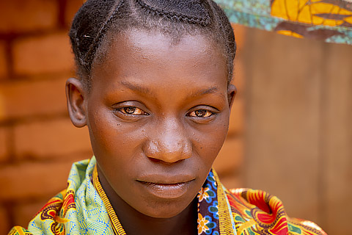



Please share this thank you video with your congregation in worship or online.

View and share video on YouTube: https://www.youtube.com/watch?v=AC9iBYU28rU

Download and share video: https://photos.lwr.org/?r=42000

