
Congregational Update
Winter 2022
Elizabeth

Dear Partner in Ministry,

Thank you for your congregation’s partnership with Lutheran World Relief. Your love is making a powerful difference around the world in the lives of our neighbors.

This document includes updates for you to share with your congregation in a variety of ways: newsletter article, bulletin announcement, social media kit and video. It is formatted so that you, your staff or volunteers can copy and paste the text directly into your congregation’s publications.

To share the photos that accompany this update, please use the link on the bottom of page 5 to access and download the images. Please do not copy the photos directly from this document.

Thank you for sharing this story with your congregation about the ways your generosity is reaching our neighbors around the world. We are deeply grateful for your partnership.

Please contact me if I can be of any assistance.



Rev. Lisa Kipp
Senior Manager of Congregational Engagement
lkipp@lwr.org
410-230-2857

We are joining Lutheran World Relief to feed families in danger.

NEWSLETTER UPDATE
Copy/paste this text into your congregation’s newsletter
For years Elizabeth Nyalam Gai, her husband and their five children managed to dodge the ongoing violence in South Sudan, keeping a low profile and scraping by as best they could. But one day a rebel militia arrived on their doorstep and killed Elizabeth’s husband, just because they could — shattering the family’s peace and security in an instant.
Elizabeth knew her only choice was to grab her children and run.

Hunger became their greatest enemy.
For seven months, Elizabeth and her children hid in the bush from soldiers and wild animals, surviving on whatever twigs, berries and bushmeat they could find. Most days, it wasn’t much.
“When [my husband] was killed, life was terrible and we went hungry,” Elizabeth recalls. “When we were hungry we would just lie down, because we had no energy.”
While her children slept, she kept watch — worrying every moment that the soldiers would find them, or that her children would starve. To truly start over, they need food.

Our congregation can help.
Elizabeth’s story is harrowing, but she’s not the only mother struggling to feed her children and keep them safe in the face of extreme adversity.

Our generosity will:
- Provide emergency food for families in crisis.
- Support longer-term efforts to support sustainable livelihoods and farming.

Our love, through Lutheran World Relief, will care for our neighbors as Christ did by feeding the hungry and caring for their needs. Until your love reaches every neighbor.

To support this effort, visit lwr.org/elizabeth [or insert specific congregational information here].

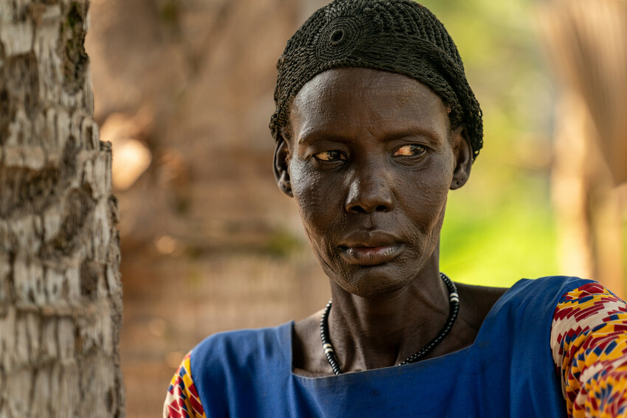
Elizabeth Nyalam Gai and her family were displaced from their home in South Sudan after her husband was killed by rebel militia. They are now staying in a camp in Mogok, after seven months living off wild fruit and twigs in the bush. Access to reliable food remains a challenge for Elizabeth and her family.

We are joining Lutheran World Relief to feed families in danger.

BULLETIN UPDATE
Copy/paste this text into your congregation’s bulletin
After rebel militia in South Sudan killed Elizabeth Nyalam Gai’s husband, she and her children were forced to run. For seven months, they hid in the bush, and hunger became their greatest enemy as they struggled to protect themselves from soldiers and wild animals. Mothers around the world are struggling to feed their children and keep them safe in the face of extreme adversity. Will you reach out in love to help our neighbors? Our generosity, through Lutheran World Relief, will provide emergency food for families in crisis as well as longer-term efforts to support sustainable livelihoods and farming… Until your love reaches every neighbor. To support this effort, visit lwr.org/elizabeth [or insert specific congregational information here].


Share this social media update on your congregation’s Facebook page. The photos included can all be downloaded at the link below. Please do not copy the photos directly from this document.
SOCIAL MEDIA UPDATE
Copy/paste this text into your congregation’s Facebook page

To share this update:
- Download the images below using this link. Please do not copy and save the photos directly from this document.
- Create a new post on your congregation’s Facebook page.
- Copy and paste the bold text below into the status message.
- Add the photos you downloaded to your post.
- Hover over the photos with your mouse and click on Edit All. Copy and paste the photo descriptions (below, to right of photos) in each photo caption box.
- Click on Done.
- Click on Post.

We are joining Lutheran World Relief to feed families in danger.

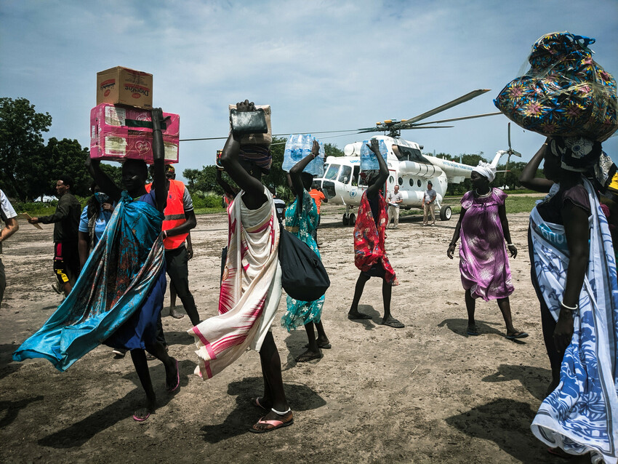
Women carry cargo from an arriving helicopter in Mogok, Jonglei State, South Sudan. There are currently 4.3 million people displaced from this troubled country, including internally displaced, asylum-seekers and refugees – 63% of whom are children. Those who are temporarily staying in the isolated Mogok camp have fled violence, flooding, and food scarcity.

Elizabeth Nyalam Gai and her family were displaced from their home in South Sudan after her husband was killed by rebel militia. They are now staying in a camp in Mogok, after seven months living off wild fruit and twigs in the bush. Access to reliable food remains a challenge for Elizabeth and her family.

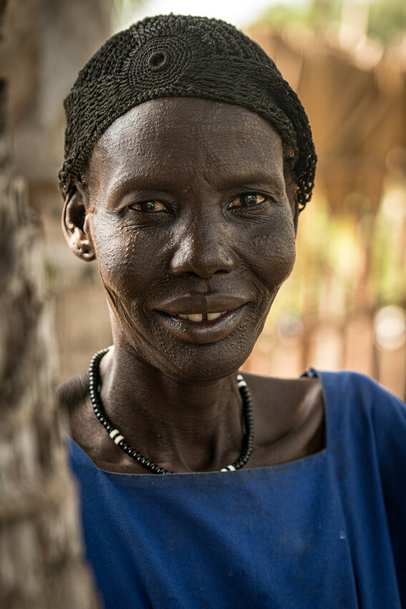
Our congregation can help reach our displaced South Sudanese neighbors, like Elizabeth and her family, with emergency food for families in crisis as well as longer-term efforts to support sustainable livelihoods and farming. To share your love with our neighbors and support this project, visit lwr.org/elizabeth [or insert congregations specific info here.]

TO DOWNLOAD AND SHARE THESE PHOTOS, VISIT:
https://photos.lwr.org/?c=3502&k=83c6bc034b

VIDEO TO SHARE
Share this video in worship or on your congregation’s Facebook page

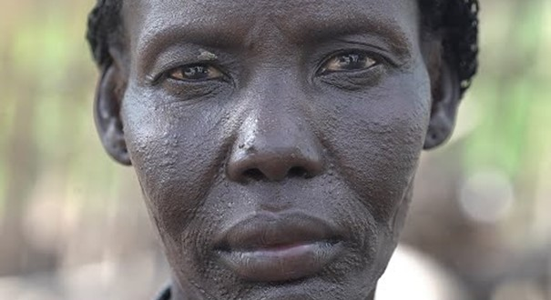

View and share video on YouTube: https://youtu.be/0GhgdlOZh8Y

Download and share video: https://photos.lwr.org/?r=37860&k=9948534691

