
Congregational Update
Fall 2021
Suzan

Dear Partner in Ministry,

Thank you for your congregation’s partnership with Lutheran World Relief. Your love is making a powerful difference around the world in the lives of our neighbors.

This document includes updates for you to share with your congregation in a variety of ways: newsletter article, bulletin announcement and social media kit. It is formatted so that you, your staff or volunteers can copy and paste the text directly into your congregation’s publications.

To share the photos that accompany this update, please use the link on the bottom of page 5 to access and download the images. Please do not copy the photos directly from this document.

Thank you for sharing this story with your congregation about the ways your generosity is reaching our neighbors around the world. We are deeply grateful for your partnership.

Please contact me if I can be of any assistance.



Rev. Lisa Kipp
Senior Manager of Congregational Engagement
lkipp@lwr.org
410-230-2857

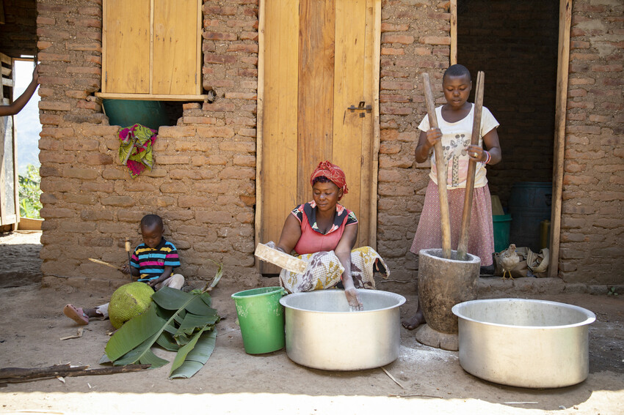
Through Lutheran World Relief, we are feeding families who would otherwise go hungry.

NEWSLETTER UPDATE
Copy/paste this text into your congregation’s newsletter

Suzan Nzabake toils on her farm, day in and day out, trying to grow coffee and vanilla the best ways she knows how. But the flowers keep dropping off her plants before the fruit has a chance to develop, and her yields are always small.
Suzan’s family lives in extreme poverty in Kasese, Uganda. They sleep on the floor of a tiny mud hut, and they have very little to eat. Her children are sick “all the time,” she says, and she has to make frequent visits to the hospital with them. Suzan often eats just once a day so there's enough food for her children to eat twice. “Our family and I survive, but life isn’t good,” she says. Still, she prays that God blesses her through her land.
Our congregation can help.
Lutheran World Relief visited Suzan’s farm to see how we could share God’s love with her family. Soil tests showed that there were very little nutrients to sustain her crops, and she had no access to fertilizer or basic farming tools.
That means no matter how hard she works, Suzan will labor in vain unless she receives training and tools to improve her yields and her income. Suzan, her children and so many others have done everything they can to help themselves. But they are poor, hungry and exhausted.
As a follower of Christ, will you extend your hand to these precious neighbors — to feed them when they are hungry? To provide what they need so they can learn to provide for themselves? Our congregation’s love can be the answer to their prayers.
Until your love reaches every neighbor.

To support this effort, visit lwr.org [or insert specific congregational information here].

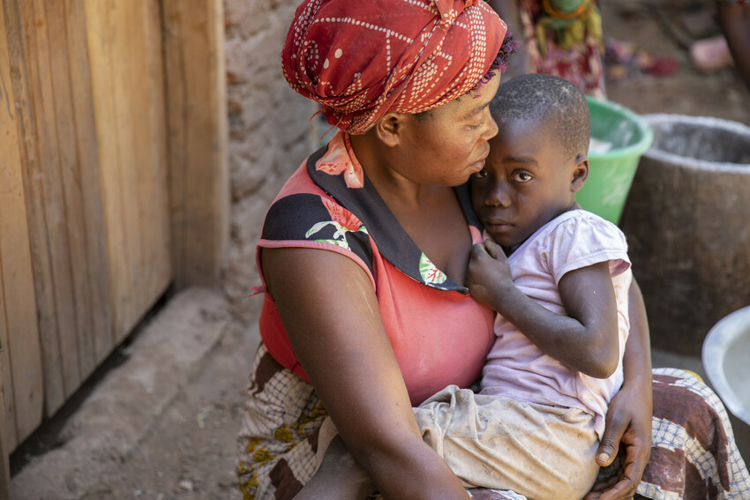

Suzan Nzabake (33) lives in a small mud shack with her family in Kasese, Uganda. She farms coffee and vanilla, but her yields are not enough to keep her children fed.

Through Lutheran World Relief, we are feeding families who would otherwise go hungry.

BULLETIN UPDATE
Copy/paste this text into your congregation’s bulletin
Suzan Nzabaka and her family live in extreme poverty in Kasese, Uganda. Suzan, her children and so many others have done everything they can to help themselves. But they are poor, hungry and exhausted. As a follower of Christ, will you extend your hand to these precious neighbors — to feed them when they are hungry? To provide what they need so they can learn to provide for themselves? Our love, through Lutheran World Relief, will ensure neighbors like Suzan, who would otherwise be forgotten, have the tools they need to grow their crops and put food on the table... Until your love reaches every neighbor. To support this effort, visit lwr.org [or insert specific congregational information here].


Share this social media update on your congregation’s Facebook page. The photos included can all be downloaded at the link below. Please do not copy the photos directly from this document.
SOCIAL MEDIA UPDATE
Copy/paste this text into your congregation’s Facebook page

To share this update:
- Download the images below using this link. Please do not copy and save the photos directly from this document.
- Create a new post on your congregation’s Facebook page.
- Copy and paste the bold text below into the status message.
- Add the photos you downloaded to your post.
- Hover over the photos with your mouse and click on Edit All. Copy and paste the photo descriptions (below, to right of photos) in each photo caption box.
- Click on Done.
- Click on Post.

Through Lutheran World Relief, we are feeding families who would otherwise go hungry.

Suzan Nzabaka’s family lives in extreme poverty in Kasese, Uganda. They sleep on the floor of a tiny mud hut, and they have very little to eat. Her children are sick “all the time,” she says, and she has to make frequent visits to the hospital with them.

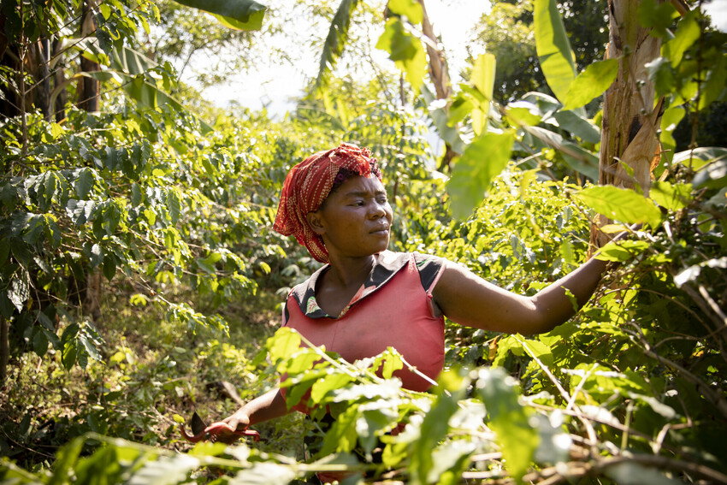
Suzan Nzabake toils on her farm, day in and day out, trying to grow coffee and vanilla with little results. Lutheran World Relief visited Suzan’s farm to see how we could share God’s love with her family. Soil tests showed that there were very little nutrients to sustain her crops, and she had no access to fertilizer or basic farming tools.

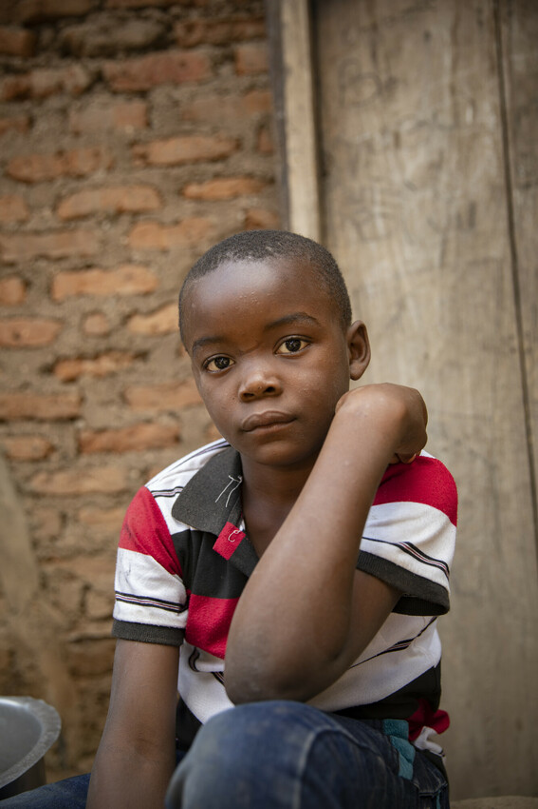
Suzan often eats just once a day so there's enough food for her children to eat twice. “Our family and I survive, but life isn’t good,” she says. “They don’t play,” she laments. “The little ones just spend time crying and dozing off.” At school, the older ones fall asleep in class because they’re hungry and have no energy. Will you share God's love?

Our congregation can help reach our neighbors around the world like Suzan and her family. Our generosity will provide training and tools to improve her yields and her income so she can feed her family.

Our love, through Lutheran World Relief, will ensure neighbors like Suzan, who would otherwise be forgotten, have the tools they need to grow their crops and feed their families… Until your love reaches every neighbor. To support this effort, visit lwr.org [or insert specific congregational information here].

TO DOWNLOAD AND SHARE THESE PHOTOS, VISIT:
https://photos.lwr.org/?c=2878&k=2af1443b7b

