
SEND EMERGENCY HELP
World of Good Emergency Response Fund

Dear Partner in Ministry,

Thank you for your congregation’s partnership with Lutheran World Relief. Your love is making a powerful difference around the world in the lives of our neighbors.

This document includes updates for you to share with your congregation in a variety of ways: bulletin or newsletter announcement, social media update and photo album. It is formatted so that you, your staff or volunteers can copy and paste the text directly into your congregation’s publications.

To share the photos that accompany this update, please use the link at the end of the document to access and download the images. Please do not copy the photos directly from this document.

Thank you for sharing this emergency appeal with your congregation. We are deeply grateful for your partnership.

Please contact me if I can be of any assistance.



Rev. Lisa Kipp
Senior Manager of Congregational Engagement
lkipp@lwr.org
410-230-2857

P.S. Gifts can be made online at www.lwr.org/help.

Or if you prefer, checks can be mailed to:
Lutheran World Relief
PO Box 17061
Baltimore, MD 21297

Please write World of Good in the memo.

Our love can save lives when disaster strikes.

BULLETIN OR NEWSLETTER ANNOUNCEMENT
Copy/paste this text into your congregation’s bulletin or newsletter

As our neighbors in Haiti mourned the loss of loved ones, homes and livelihoods following the August 14 earthquake, the love of U.S. Lutherans reached them in the form of emergency food, clean water, tarps, hygiene kits and medical care to weather the crisis.

Tragically, dangerous tropical storms, hurricanes, floods, earthquakes and other life-threatening disasters are on the rise. And it’s our poorest neighbors who suffer the most when disaster hit.

But our congregation’s financial gifts can save lives and offer hope quickly when disasters strike. Through a gift to Lutheran World Relief’s Word of Good Emergency Response Fund, our love can reach neighbors in the immediate hours following a disaster and provide hope when it’s needed most.

WAYS TO GIVE
- Give online at lwr.org/help
- Mail a check to: Lutheran World Relief, PO Box 17061, Baltimore, MD 21297.
Please write World of Good in the memo
- [or insert specific giving options for your congregation here]

TO DOWNLOAD AND SHARE PHOTOS WITH THIS ANNOUNCEMENT, VISIT:
https://photos.lwr.org/pages/search.php?search=%21collection3376&k=6a16f054eb


Share this social media update on your congregation’s Facebook page. The photos included can all be downloaded at the link below. Please do not copy the photos directly from this document.
SOCIAL MEDIA UPDATE
Copy/paste this text into your congregation’s Facebook page

To share this update:
- Download the images below using this link. Please do not copy and save the photos directly from this document.
- Create a new post on your congregation’s Facebook page.
- Copy and paste the bold, blue text below into the status message.
- Add the photos you downloaded to your post.
- Hover over the photos with your mouse and click on Edit All. Copy and paste the photo descriptions (below, to right of photos) in each photo caption box.
- Click on Done.
- Click on Post.

Our love can save lives when disasters strike.

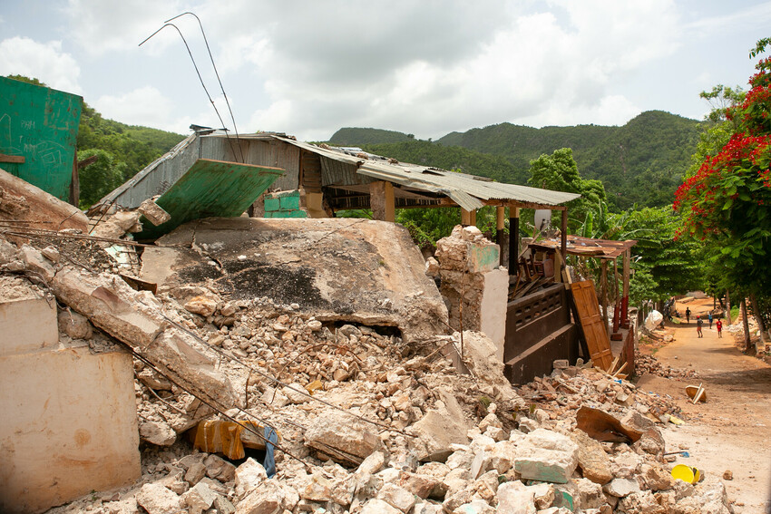
A devastating 7.2 magnitude earthquake struck our neighbors in Haiti on August 14 – a brutal blow to this impoverished country still recovering from the disastrous 2010 quake and fighting a surge of coronavirus infections. Roads are inaccessible throughout many regions of the country.

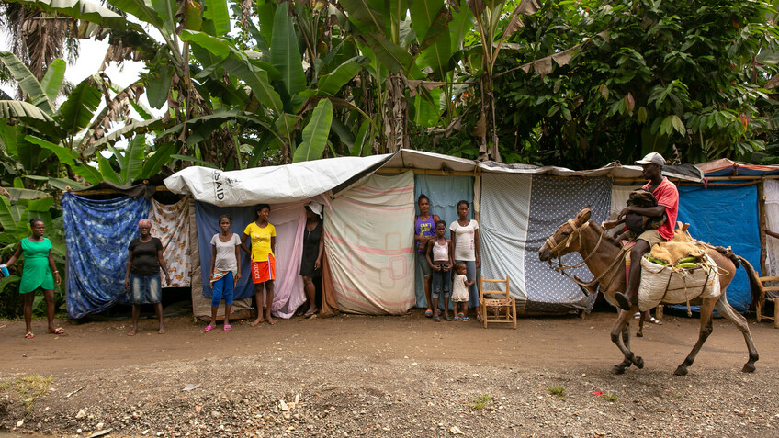
Families stand in front of their makeshift dwellings, tent-sized shelters made of tarps and wood, along the side of the road near Chambellan, in the Grand’Anse department of Haiti, one week after the earthquake that destroyed their homes.

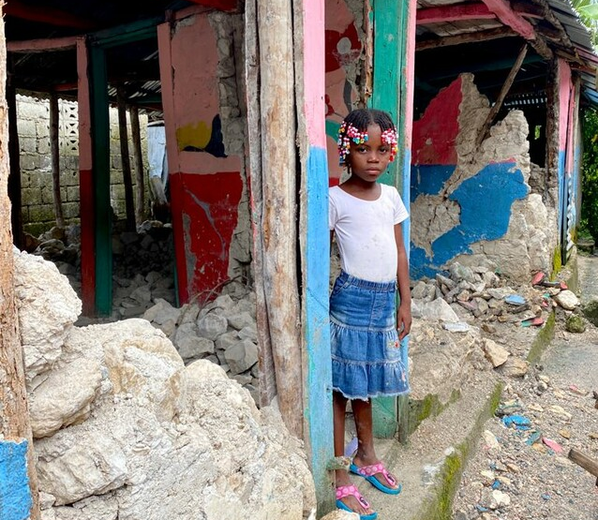
Onella Michel, 6, stands in the ruins of her school in Chamberllan, Haiti, one week after the 7.2 earthquake that devasted much of the region. “I was trembling,” said Onella of that day. She escaped harm by the quick action of her mother, who grabbed her hand and ran her to the street as soon as the shaking began.

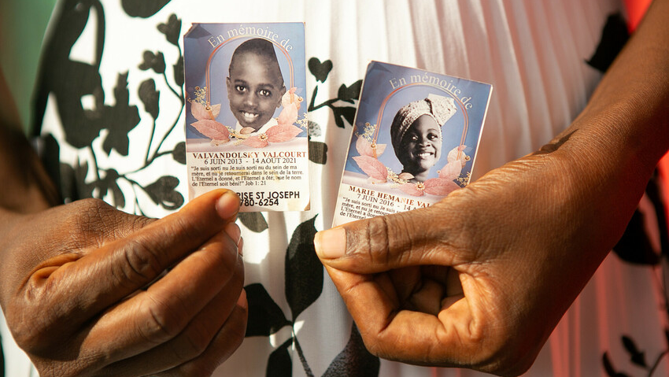
Marie Entonnance Dely, 45, holds photos of her nephew Valvandolsky Valcourt, 8 and Marie Hemanie Valcourt, 5, who were killed when their home in downtown Jeremie, Haiti collapsed in the August 14 earthquake. The two had been playing video games on the couch. Dely says that it took over three hours to dig them out and that passersby were more interested in looting the grocery depot next door than helping.

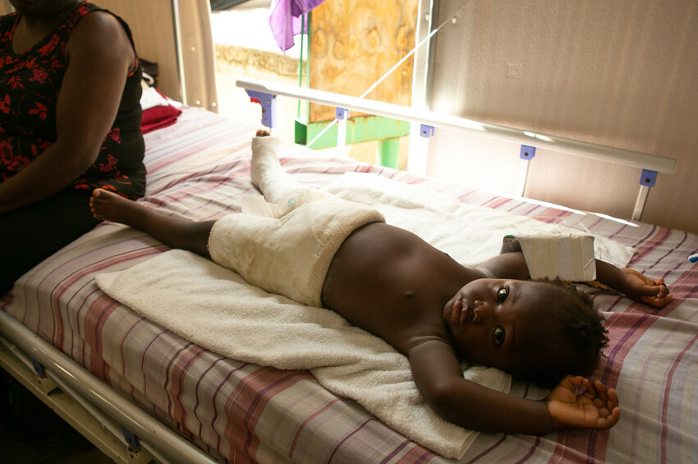
Islande Joseph helps a nurse administer medication to her son Evenson Dorvil, 22 months, at St. Antoine Hospital in Jeremie, Haiti. Evenson suffered extensive injuries, including a complete fracture to his right leg, when a wall of the family home fell on him during the earthquake. The house was totally destroyed.

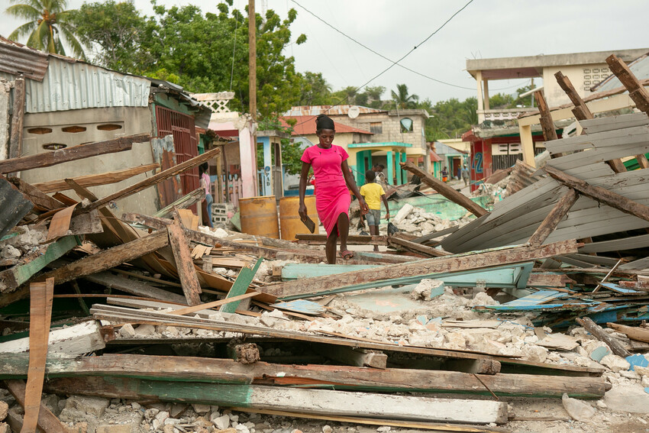
By making a gift to Lutheran World Relief’s emergency response fund, your love does a world of good for families in crisis and provides hope when it’s needed most. Please make a gift today at www.lwr.org/help and let our must vulnerable neighbors know that Lutherans in the United States care for them.

TO DOWNLOAD AND SHARE THESE PHOTOS, VISIT:
https://photos.lwr.org/pages/search.php?search=%21collection3376&k=6a16f054eb

PHOTO ALBUM
Download and share these images with your congregation

TO DOWNLOAD AND SHARE ANY OF THE PHOTOS IN THIS DOCUMENT, VISIT:
https://photos.lwr.org/pages/search.php?search=%21collection3376&k=6a16f054eb

