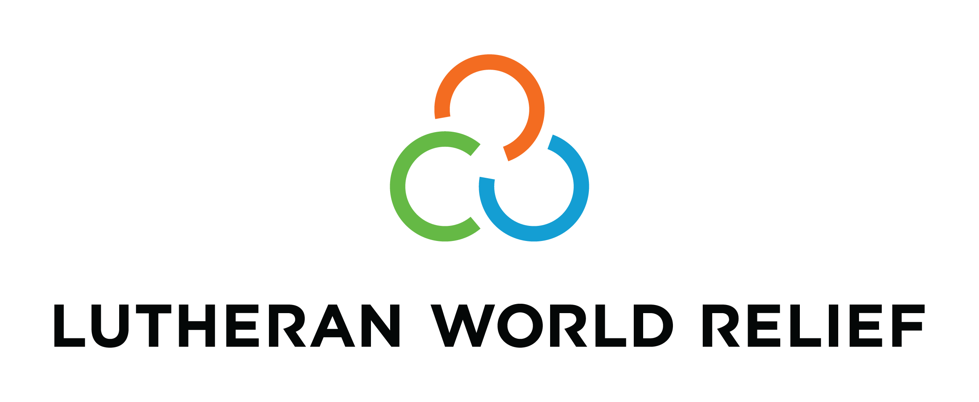
Congregational Update
Summer 2021
Aisata

Dear Partner in Ministry,

Thank you for your congregation’s partnership with Lutheran World Relief. Your love is making a powerful difference around the world in the lives of our neighbors.

This document includes updates for you to share with your congregation in a variety of ways: newsletter article, bulletin announcement, social media kit, and video. It is formatted so that you, your staff or volunteers can copy and paste the text directly into your congregation’s publications.

To share the photos that accompany this update, please use the link on the bottom of page 5 to access and download the images. Please do not copy the photos directly from this document.

Thank you for sharing this story with your congregation about the ways your generosity is reaching our neighbors around the world. We are deeply grateful for your partnership.

Please contact me if I can be of any assistance.



Rev. Lisa Kipp
Senior Manager of Congregational Engagement
lkipp@lwr.org
410-230-2857

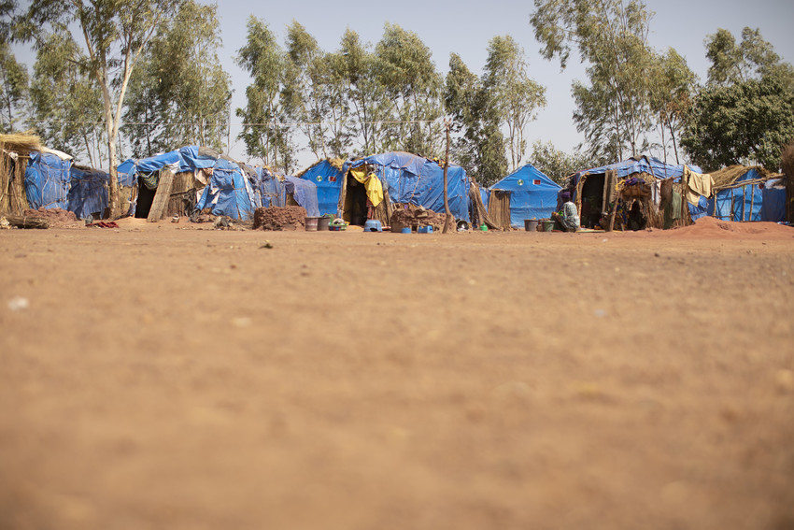
We are joining Lutheran World Relief to end this pandemic for everyone, everywhere.

NEWSLETTER UPDATE
Copy/paste this text into your congregation’s newsletter

More than a thousand people live under tarps in a dusty camp called Senou on the outskirts of Bamako, Mali’s capital city.

These families are the innocent bystanders of Mali’s ongoing war. When violence finally drove them from their homes in West Africa, often with nothing but the clothes on their backs, they found relative peace in this makeshift camp. But still, though shielded from gunfire, they are far from safe.

These families are living in one of worst humanitarian crises in the world. There are no jobs. There is no food, because there is no rain. Only the kindness of strangers keeps them alive.

Are safety, security and hope too much to ask?

Senou resident Aisata Dicko has known untold suffering in her 40 years of life. The last straw was witnessing her 13-year-old son being killed by insurgents more than two years ago. Heartbroken, she grabbed her other children and fled central Mali, the only home they’ve ever known, to seek safety in the camp.

Aisata’s family has so many needs as they struggle to survive day by day. The last thing they need is COVID-19. But she and her neighbors are not sure whether a COVID vaccine will ever reach them. After all, they often go a day or more without anything to eat.

Our congregation can help.
Though many of us in the U.S. have begun to resume normal activities, the pandemic continues to affect poor and vulnerable communities who desperately need basics like food and water and an opportunity to be vaccinated against COVID-19. Will you reach out in love to help our neighbors?

Our generosity will:
- Equip clinics to receive and store the vaccine.
- Train health care workers to coordinate vaccination campaigns.
- Provide essentials for survival, including masks, clean water and emergency food assistance.

Our love, through Lutheran World Relief, will help to ensure the largest global health effort in human history reaches the dusty camps, poorest slums and most remote villages... Until your love reaches every neighbor.

To support this effort, visit lwr.org [or insert specific congregational information here].
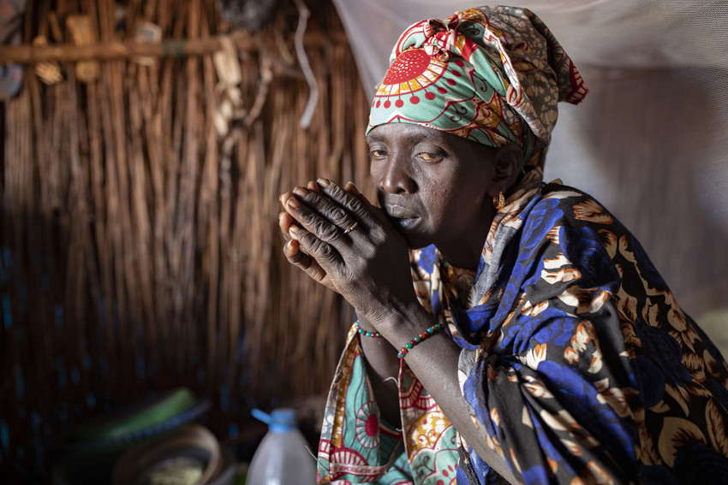

Aisata Dicko (40) fled the insecurity in central Mali after watching her 13-year-old son being killed by insurgents. She and her children have lived together in a displacement camp for the last two years. Social distancing is impossible. Aisata and her neighbors fear the arrival of COVID-19.

We are joining Lutheran World Relief to end this pandemic for everyone, everywhere.

BULLETIN UPDATE
Copy/paste this text into your congregation’s bulletin
Though many of us in the U.S. have begun to resume normal activities, the pandemic continues to affect poor and vulnerable communities who desperately need basics like food and water and an opportunity to be vaccinated against COVID-19. Will you reach out in love to help our neighbors? Our generosity will equip clinics to receive and store the vaccine; train health care workers to coordinate vaccination campaigns; and provide essentials for survival, including masks, clean water and emergency food assistance. Our love, through Lutheran World Relief, will help to ensure the largest global health effort in human history reaches the dusty camps, poorest slums and most remote villages… Until your love reaches every neighbor. To support this effort, visit lwr.org [or insert specific congregational information here].


Share this social media update on your congregation’s Facebook page. The photos included can all be downloaded at the link below. Please do not copy the photos directly from this document.
SOCIAL MEDIA UPDATE
Copy/paste this text into your congregation’s Facebook page

To share this update:
- Download the images below using this link. Please do not copy and save the photos directly from this document.
- Create a new post on your congregation’s Facebook page.
- Copy and paste the bold text below into the status message.
- Add the photos you downloaded to your post.
- Hover over the photos with your mouse and click on Edit All. Copy and paste the photo descriptions (below, to right of photos) in each photo caption box.
- Click on Done.
- Click on Post.

We are joining Lutheran World Relief to end this pandemic for everyone, everywhere.

More than a thousand people live under these tarps in a dusty camp called Senou on the outskirts of Bamako, Mali’s capital city. These families are the innocent bystanders of Mali’s ongoing war. When violence finally drove them from their homes in West Africa, often with nothing but the clothes on their backs, they found relative peace in this makeshift camp. But still, though shielded from gunfire, they are far from safe.

Senou resident Aisato Dicko has known untold suffering in her 40 years of life. The last straw was witnessing her 13-year-old son being killed by insurgents more than two years ago. Heartbroken, she grabbed her other children and fled central Mali, the only home they’ve ever known, to seek safety in the camp.

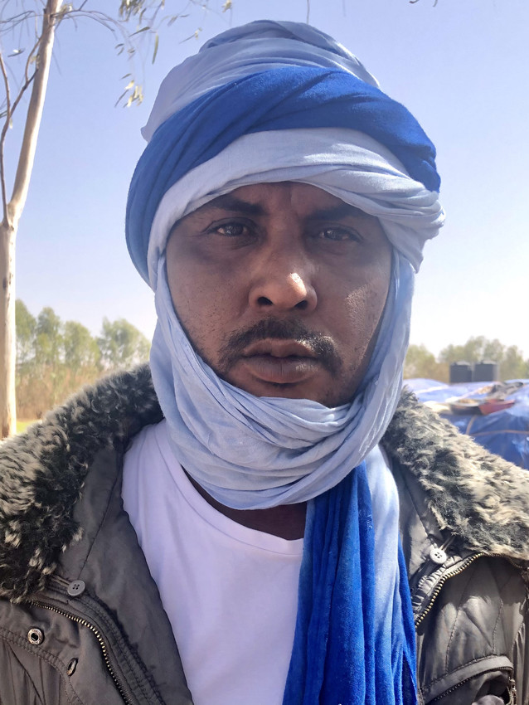
Oumar Dicko is the elected leader of Senou Camp and fears the arrival of COVID-19. “These tents are so close together,” he says, looking out on the sea of tents. “If we get even one case here, I know everyone will get it. We know about the vaccine. We know supply is not sufficient, and we know it’s hard to get.”

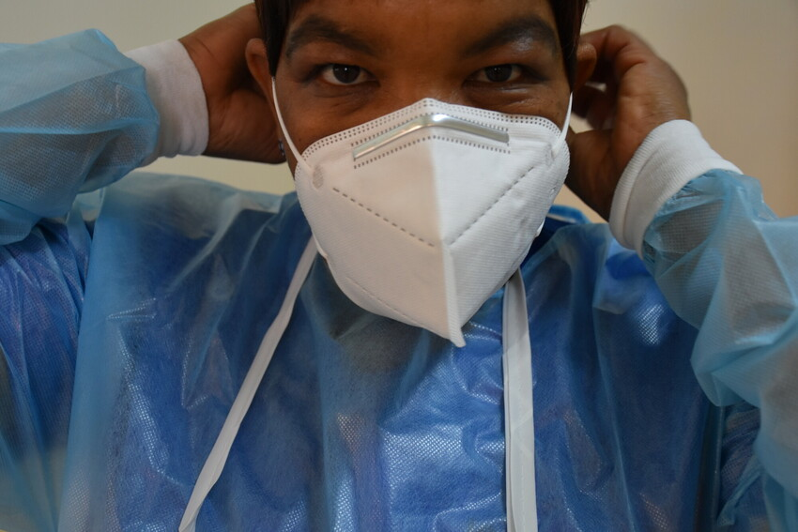
Our congregation can help reach our neighbors around the world with essentials needed to fight COVID-19. Our generosity will equip clinics to receive and store the vaccine; train health care workers to coordinate vaccination campaigns; and provide essentials for survival, including masks, clean water and emergency food assistance.

Our love, through Lutheran World Relief, will help to ensure the largest global health effort in human history reaches the dusty camps, poorest slums and most remote villages… Until your love reaches every neighbor. To support this effort, visit lwr.org [or insert specific congregational information here].

TO DOWNLOAD AND SHARE THESE PHOTOS, VISIT:
https://photos.lwr.org/?c=3313&k=16e4d09362

VIDEO TO SHARE
Share this video in worship or on your congregation’s Facebook page
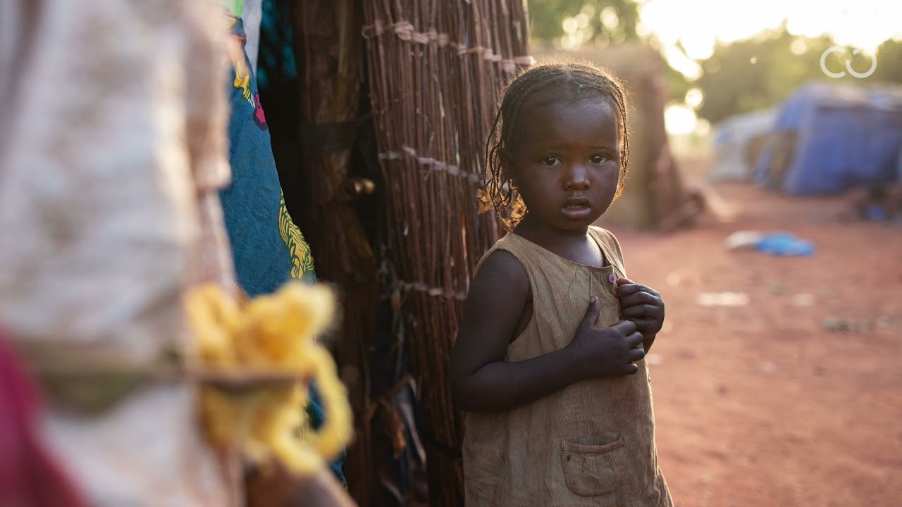

View and share on YouTube here: https://youtu.be/D6R-_pQM3Rs

Download and share here: https://photos.lwr.org/?r=34208&k=308e233aee

