
Congregational Update
Summer 2021
Elsa

Dear Partner in Ministry,

Thank you for your congregation’s partnership with Lutheran World Relief. Your love is making a powerful difference around the world in the lives of our neighbors.

This document includes updates for you to share with your congregation in a variety of ways: newsletter article, bulletin announcement and a social media kit. It is formatted so that your staff or volunteers can copy and paste the text directly into your congregation’s publications.

To share the photos that accompany this update, please use the link at the end of the document to access and download the images. Please do not copy the photos directly from this document.

Thank you for sharing this story with your congregation about the ways your generosity is reaching our neighbors around the world. We are deeply grateful for your partnership.

Please contact me if I can be of any assistance.



Rev. Lisa Kipp
Senior Manager, Congregations
lkipp@lwr.org
410-230-2857

Back-to-back hurricanes destroyed homes, jobs and hope in Central America.

NEWSLETTER UPDATE
Copy/paste this newsletter text into your own congregational newsletter
With Lutheran World Relief, we can help our neighbors recover and rebuild.

Elsa Marina Amaya was just a child when her entire village of Waller Bordo, Honduras, was destroyed by Hurricane Mitch in 1998. The destruction was so complete that everyone carried their few remaining belongings across the river to rebuild the village on higher ground.

Today Elsa is 30, and she has three young daughters of her own — ages 9, 3 and 6 months. When back-to-back storms Eta and Iota swept through her village last fall, they brought a level of devastation that Elsa and her neighbors had hoped they’d never see again.

Even before the storms hit less than two weeks apart in November 2020, Elsa was struggling to make ends meet. In fact, half of all families living in the low-lying areas near San Pedro Sula, Honduras — one of the poorest places in the world — didn’t know where their next meal was coming from.

In the past, Elsa has provided for her family by working as a cook. But when COVID-19 reached Central America last spring, all the kitchens closed and her income dried up. By the time the storms came, she had been unable to find work for months.

Elsa told Lutheran World Relief that her biggest needs right now are food, diapers, milk, medicine and vitamins for her children — only the very basics for their health and survival.

Elsa isn’t alone. While most of the homes in Waller Bordo were spared the worst of the damage, the storms’ heavy rains completely wiped out the village’s primary livelihoods — corn and palm oil production. Their hard work and hope for the future were literally swept away. Now these families have no idea how they’ll feed their children or pay their bills in the months to come.

What Elsa and her family need today is love, and our congregation can help.

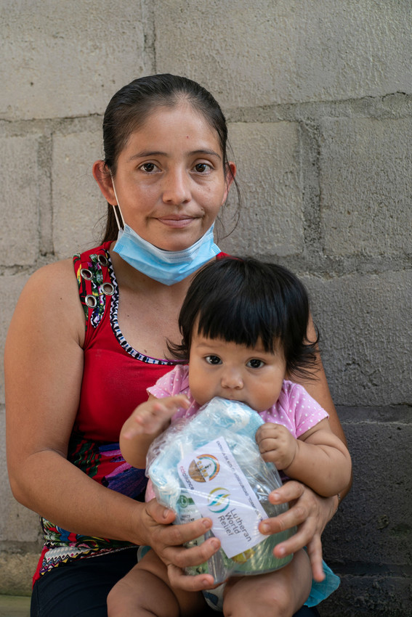
With your gift, you can share love with your neighbors affected by Hurricanes Eta and Iota in the form of food, water, safe temporary shelter, tools and building supplies. Your generosity will also walk alongside these families in the years to come, as they rebuild homes and restore crops and livelihoods. Your gift will also help in our urgent efforts to get COVID-19 vaccines into the arms of people who are at high risk in countries like Honduras.

You can support our partnership with Lutheran World Relief by [insert your congregation’s giving instructions here].

By reaching out in love, we can be the difference between life and death for people like Elsa and her children.

Elsa told Lutheran World Relief that her biggest needs right now are food, diapers, milk, medicine and vitamins for her children – only the very basics for their health and survival.

When walls crumble and levees break, love never fails.

BULLETIN UPDATE
Copy/paste this text into your own congregational bulletin
Elsa Marina Amaya was just a child when her entire village of Waller Bordo, Honduras, was destroyed by Hurricane Mitch in 1998. Today Elsa is 30, and she has three young daughters of her own — ages 9, 3 and 6 months. When back-to-back storms Eta and Iota swept through her Central American village last fall, they brought a level of devastation that Elsa and her neighbors had hoped they’d never see again. And with the impact of COVID-19 on top of the destruction caused by the hurricanes to this region – one of the poorest places in the world – families have no idea how they’ll feed their children or pay their bills in the months to come. What Elsa and her family need today is love, and our congregation can help. To learn more about how you can share your love with neighbors like Elsa through Lutheran World Relief, see this month’s newsletter article or visit lwr.org.



Share this social media update on your congregation’s Facebook page. The photos included below can all be downloaded at this link. Please do not copy the photos directly from this document.

SOCIAL MEDIA UPDATE
Copy/paste this newsletter text into your own congregational bulletin

To share this update:
- Download the images below using this link. Please do not copy and save the photos directly from this document.
- Create a new post on your congregation’s Facebook page.
- Copy and paste the bold text below into the status message.
- Add the photos you downloaded to your post.
- Hover over the photos with your mouse and click on Edit All. Copy and paste the photo descriptions (below, to right of photos) in each photo caption box.
- Click on Done.
- Click on Post.

Back-to-back hurricanes destroyed homes, jobs and hope in Central America. With Lutheran World Relief, we can help our neighbors recover and rebuild.

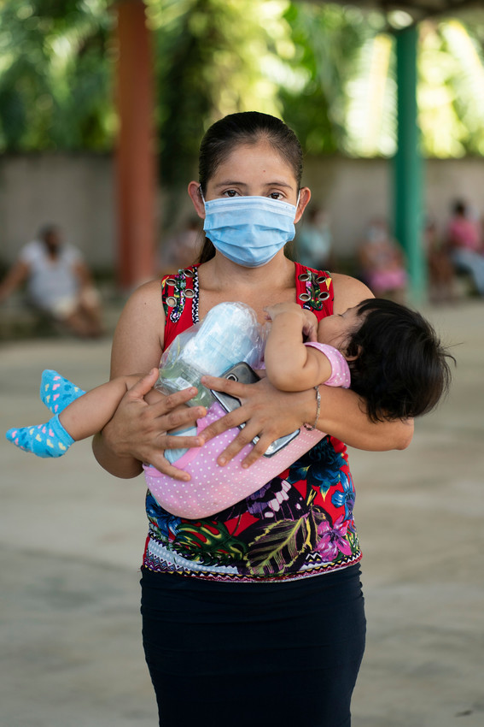
Elsa Marina Amaya was just a child when her entire village of Waller Bordo, Honduras was destroyed by Hurricane Mitch in 1998. The destruction was so complete that everyone carried their few remaining belongings across the river to rebuild the village on higher ground.

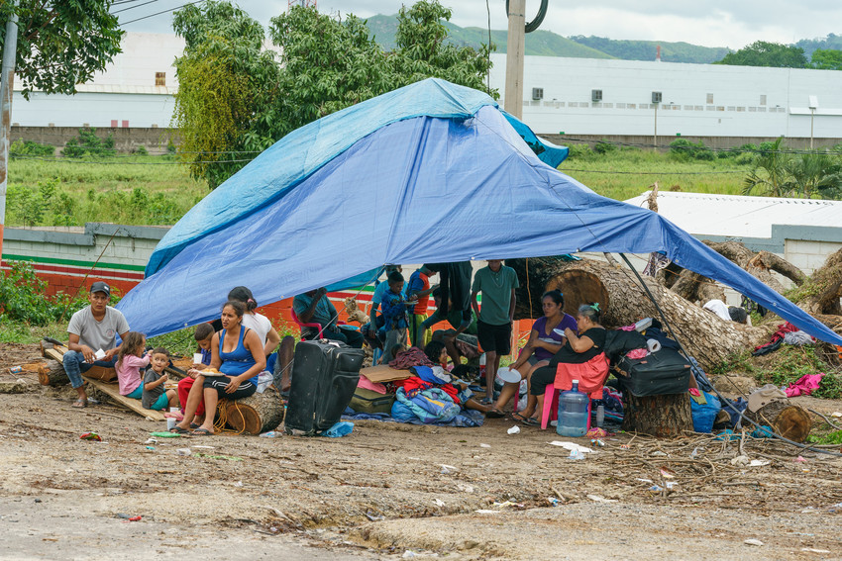
When back-to-back hurricanes Eta and Iota swept through her Central American village last fall, they brought a level of devastation that Elsa and her neighbors had hoped they’d never see again.

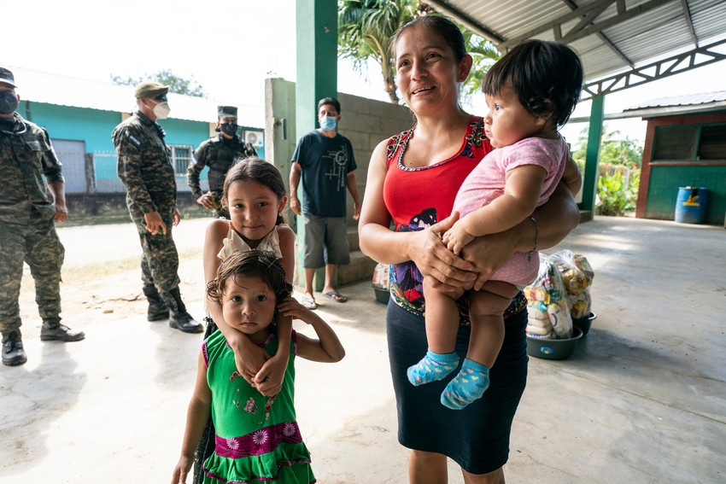
Today Elsa is 30, and she has three young daughters of her own — ages 9, 3 and 6 months. With the impact of COVID-19 on top of the destruction caused by the hurricanes to this region – one of the poorest places in the world – mothers like Elsa have no idea how they’ll feed their children or pay their bills in the months to come.

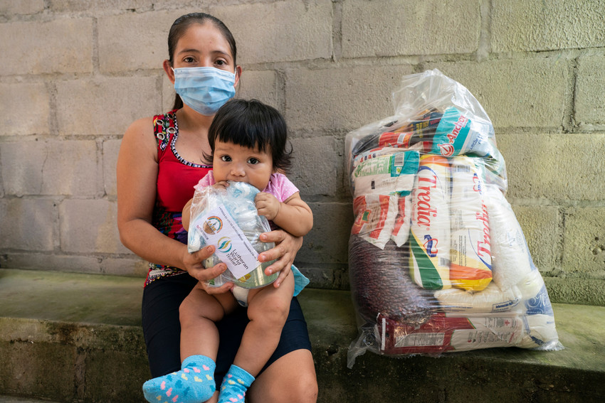
Elsa told Lutheran World Relief that her biggest needs right now are food, diapers, milk, medicine and vitamins for her children — only the very basics for their health and survival.

What Elsa and her family need today is love, and our congregation can help. To learn more about how you can share your love with neighbors like Elsa through Lutheran World Relief, see this month’s newsletter article or visit lwr.org.

TO DOWNLOAD AND SHARE THESE PHOTOS OF RAJENDRA AND HIS FAMILY, VISIT:
https://photos.lwr.org/?c=3160&k=dbc024b4ae

