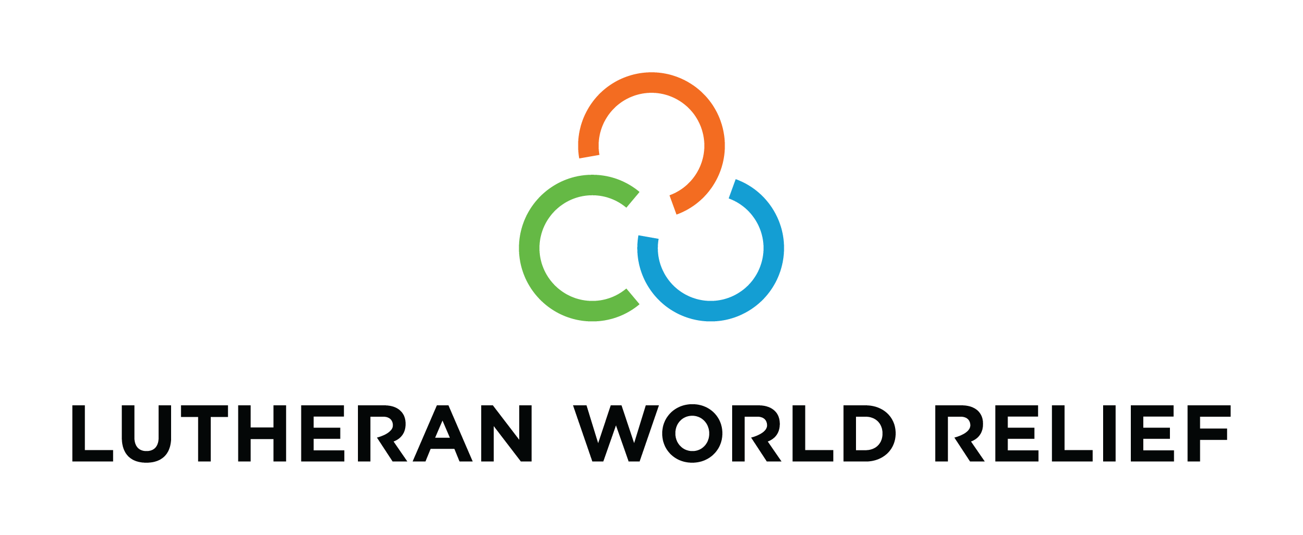
Congregational Update
Winter 2021
Personal Care Kits

Dear Partner in Ministry,

Thank you for your congregation’s partnership with Lutheran World Relief. Your love is making a powerful difference around the world in the lives of our neighbors.

This document includes updates for you to share with your congregation in a variety of ways: newsletter article, bulletin announcement, social media kit and video. It is formatted so that your staff or volunteers can copy and paste the text directly into your congregation’s publications.

To share the photos that accompany this update, please use the link at the end of the document to access and download the images. Please do not copy the photos directly from this document.

Thank you for sharing this story with your congregation about the ways your generosity is reaching our neighbors around the world. We are deeply grateful for your partnership.

Please contact us if we can be of any assistance.

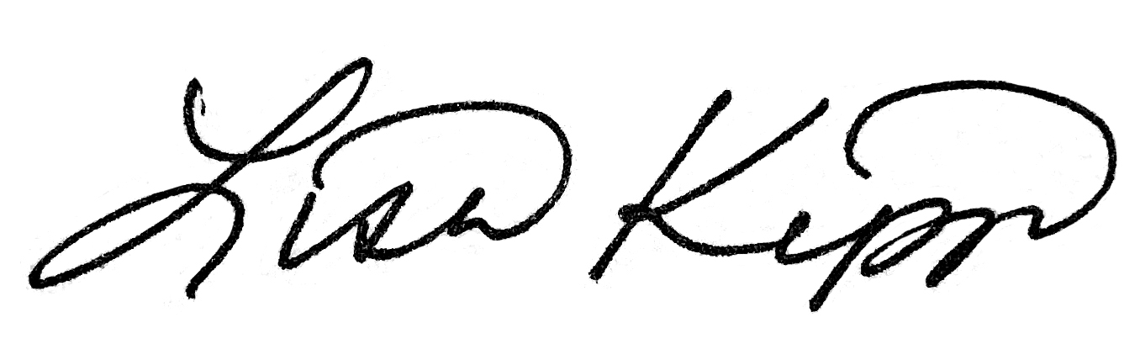

Rev. Lisa Kipp
Senior Manager, Congregations
lkipp@lwr.org
800-597-5972

<NEWSLETTER UPDATE>

Our neighbors need Lutheran World Relief Personal Care Kits

Few of us could predict what 2020 would hold. We didn’t know how long our church doors would remain closed. We didn’t know just how much our technological skills (and our patience) would be stretched and tested over the coming seasons. We couldn’t know what it would be like to weather the wilderness of a global pandemic.

Meanwhile, this year of challenge, loss and uncertainty hit our poorest neighbors around the world even harder.

The COVID-19 pandemic brought more than a disease to our most vulnerable neighbors. In some communities it has meant hunger, as they’ve been cut off from food, seeds and critical farming supplies. In others, it has meant getting sick or dying from malaria, HIV or childbirth because health centers are stretched too thin — or because people are afraid to seek the help they need, fearing they will catch the coronavirus at the hospital. The past year also brought devastating disasters, one after another. A massive explosion in Beirut killed hundreds and left 300,000 homeless. Back-to-back hurricanes in Central America decimated the crops and modest homes of people who were already living in grinding poverty. In fact, the punishing effects of war and poverty on our most forsaken neighbors did not ease up in the face of COVID-19 — they only worsened.

You can put God’s love in action

Because of these realities, many of us are beginning 2021 with heavy hearts. We are restless; we want justice. We want to be the hands and feet of Christ for our brothers and sisters. After a year of feeling stifled, we want to DO SOMETHING to make a real and tangible difference in a world groaning for hope and relief.

Between COVID-19 and the many challenges of 2020, the need for Lutheran World Relief Personal Care Kits around the world has grown and intensified. Meanwhile, LWR warehouse shelves are almost empty.

But your love can make a difference. People of every age can share God’s love by making LWR Personal Care Kits — whether in individual families or in groups. Please visit lwr.org/kits to access all the instructions you will need to put God’s love in action.

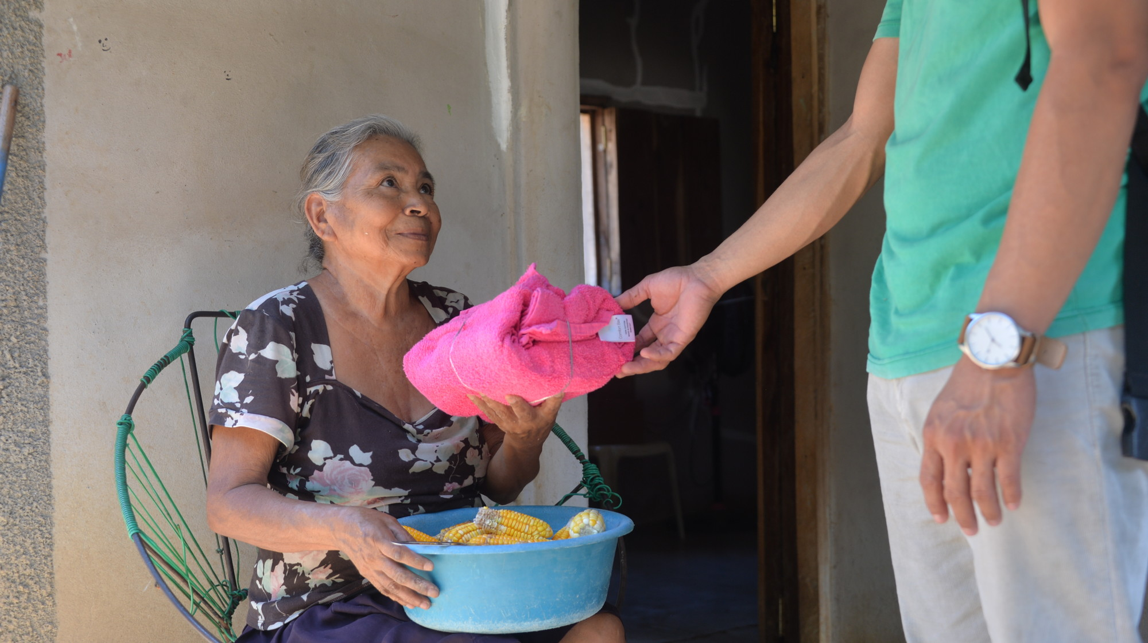
Maria Teresa Jesus receives an LWR Personal Care Kit in San Jose, Honduras, following Hurricanes Eta and Iota. The community suffered an outbreak of COVID-19 earlier in 2020. Local health officials hope LWR personal care kits will help to curb another outbreak while people are displaced due to the storms.

<BULLETIN UPDATE>

Our neighbors need Lutheran World Relief Personal Care Kits
The COVID-19 pandemic brought more than a disease to our most vulnerable neighbors. In some communities it has meant hunger, as they’ve been cut off from food, seeds and critical farming supplies. In others, it has meant getting sick or dying from malaria, HIV or childbirth because health centers are stretched too thin — or because people are afraid to seek the help they need, fearing they will catch the coronavirus at the hospital. The past year also brought devastating disasters, one after another. A massive explosion in Beirut killed hundreds and left 300,000 homeless. Back-to-back hurricanes in Central America decimated the crops and modest homes of people who were already living in grinding poverty. Between COVID-19 and the many challenges of 2020, the need for LWR Personal Care Kits around the world has grown and intensified. Meanwhile, LWR warehouse shelves are almost empty. But your love can make a difference. People of every age can share God’s love by making LWR Personal Care Kits — whether in individual families or in groups. Please visit lwr.org/kits to access all the instructions you will need to put God’s love in action.

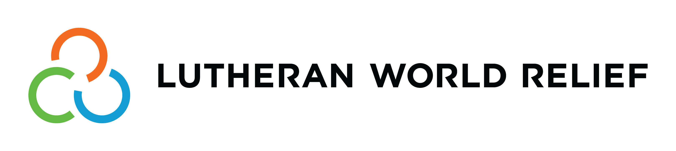
<SOCIAL MEDIA UPDATE>

Share this social media update on your congregation’s Facebook page. The photos included below can all be downloaded at this link. Please do not copy the photos directly from this document.

To share this update:
- Download the images below using this link. Please do not copy and save the photos directly from this document.
- Create a new post on your congregation’s Facebook page.
- Copy and paste the bold text below into the status message.
- Add the photos you downloaded to your post.
- Hover over the photos with your mouse and click on Edit All. Copy and paste the photo descriptions (below, to right of photos) in each photo caption box.
- Click on Done.
- Click on Post.

Between COVID-19 and the many challenges of the past year, the need for Lutheran World Relief Personal Care Kits around the world has grown and intensified. Meanwhile, LWR warehouse shelves are almost empty.

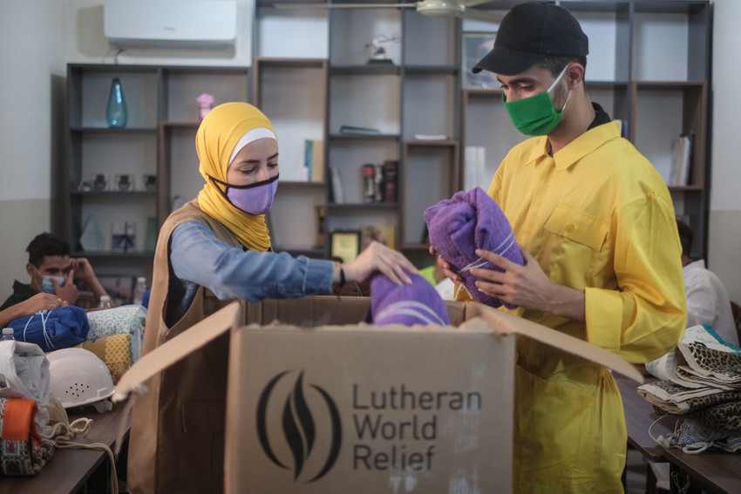
An LWR Personal Care Kit is designed to help your neighbors coping with poverty, disaster, conflict and more by helping to maintain good hygiene and fight off infection. Containing a towel, soap, toothbrush, comb and nail clippers, an LWR Personal Care Kit helps to provide dignity and hope.

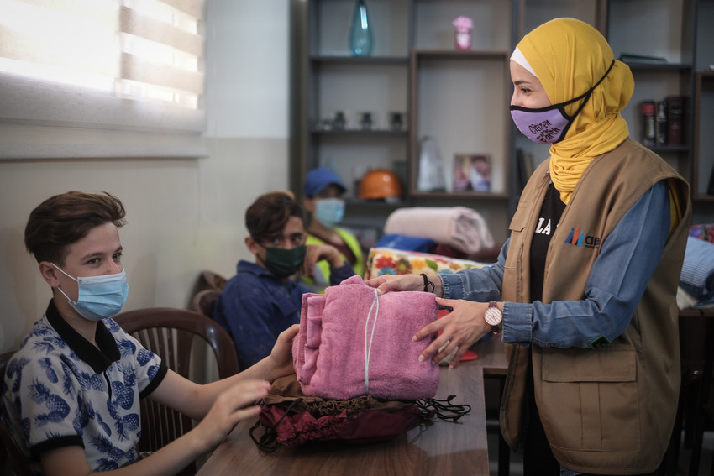
YOU can make a difference! People of every age can share God’s love by making LWR Personal Care Kits — whether in individual families or in groups.

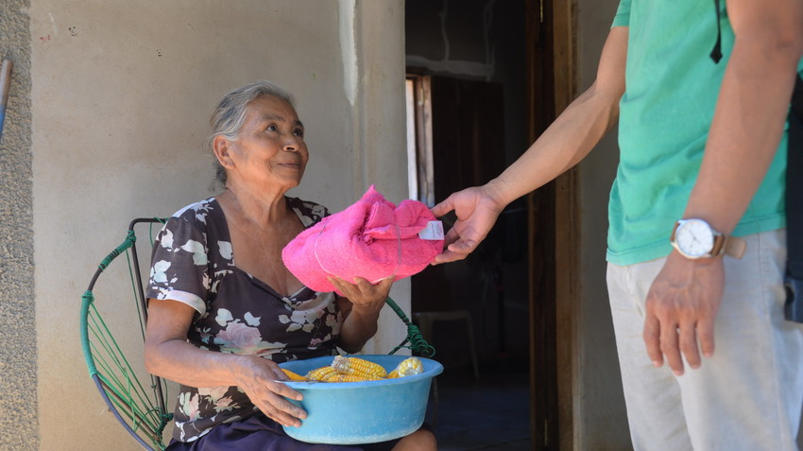
Your love will meet people like Maria Teresa Jesus. Maria lives in San Jose, Honduras. There was an outbreak of COVID-19 in her community, followed by devastation when Hurricanes Eta and Iota made landfall in Central America. Local health officials hope LWR Personal Care Kits will help to curb another COVID-19 outbreak while people are displaced due to the storms.

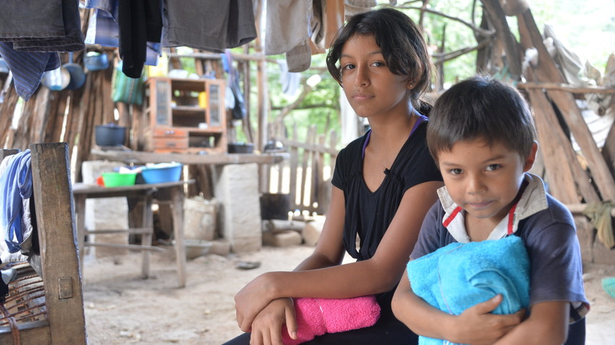
To learn more about how YOU can assemble Personal Care Kits and share God’s love with your neighbors around the world, visit lwr.org/kits.

TO DOWNLOAD AND SHARE THESE PHOTOS OF PERSONAL CARE KITS, VISIT:
https://photos.lwr.org/?c=3074&k=9f20c87560

<VIDEO ENGAGEMENT>

On August 4, 2020, one of the largest non-nuclear explosions ever recorded sent a blast through Beirut, Lebanon. More than 180 people were killed and an estimated 300,000 were displaced. At first report, LWR was informed that shipping containers filled with more than 20,000 LWR quilts and kits were destroyed. Upon further inspection, the containers survived the blast and all of the quilts and kits have been distributed to families in need. Watch and share this video with your congregation. And thank you for sharing God’s love with our neighbors around the world through assembling Personal Care Kits!

Bringing Christ’s light to life in Beirut



TO VIEW AND SHARE THIS VIDEO VIA YOUTUBE, VISIT:
https://youtu.be/JIrXrgGbB5U

TO DOWNLOAD AND SHARE THIS VIDEO, VISIT:
https://photos.lwr.org/?c=3074&k=9f20c87560

