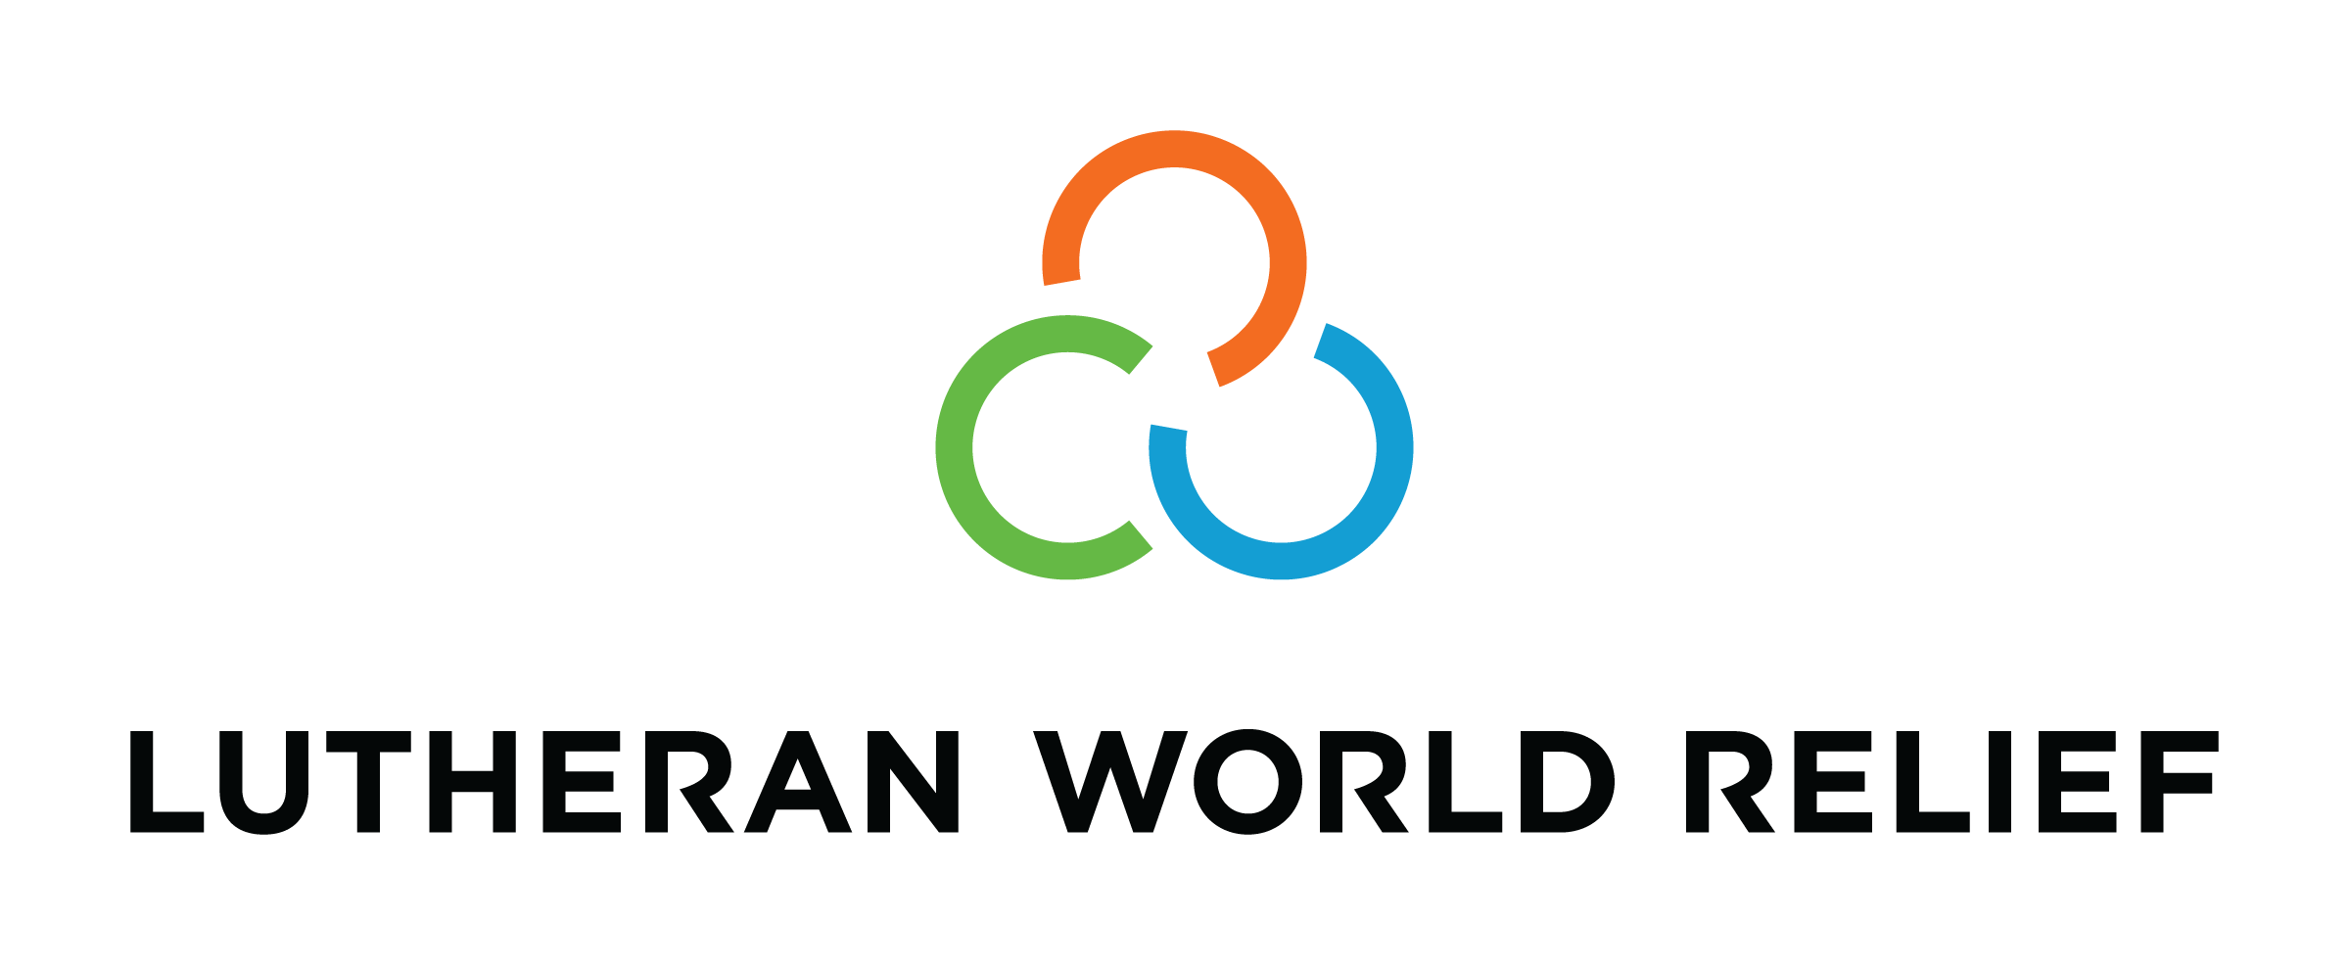
Congregational Update
Fall 2020
Lilian

Dear Partner in Ministry,

Thank you for your congregation’s partnership with Lutheran World Relief. Your love is making a powerful difference around the world in the lives of our neighbors.

This document includes updates for you to share with your congregation in a variety of ways: newsletter article, bulletin announcement, social media kit and video. It is formatted so that your staff or volunteers can copy and paste the text directly into your congregation’s publications.

To share the photos that accompany this update, please use the link at the end of the document to access and download the images. Please do not copy the photos directly from this document.

Thank you for sharing this story with your congregation about the ways your generosity is reaching our neighbors around the world. We are deeply grateful for your partnership.

Please contact me if I can be of any assistance.

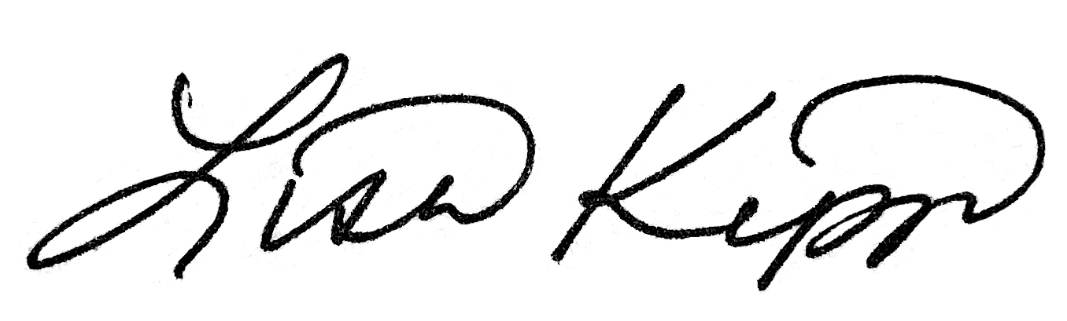

Rev. Lisa Kipp
Senior Manager, Congregations
lkipp@lwr.org
612-248-2219

<NEWSLETTER UPDATE>

They have love in their home, but not clean water

Lilian Mutheu grew up in Mukuru, one of the largest slums in Nairobi, Kenya. The living conditions in Mukuru are some of the worst imaginable. The streets are littered with trash and waste, and communicable diseases like COVID-19 spread quickly due to cramped conditions and a lack of clean water and sanitation.

But Lilian was a bright girl, and she did everything she could to lift herself out of poverty. She studied hard and got a job, but she ran into challenge after challenge in trying to rise above her circumstances. The men at work sexually harassed her, making it clear she would advance only if she gave into their demands.

Still, Lilian persisted. She continued working and hoped to save money for her future, but soon her mother began demanding all of Lilian’s wages. When Lilian wouldn’t comply, her mother packed Lilian’s belongings into a single suitcase and threw her onto the street.

Lilian had tried to do everything right, but now she was alone, forsaken. Years later, she still breaks down in tears whenever she remembers. Her only option was to move in with her boyfriend. Before long, Lilian became pregnant, and her rise out of poverty became even steeper.

A better life, starting with water

Lilian looks at her son Nevil, now four years old, with deep love in her eyes, and she would not trade him for the world. She continues to work hard with the hope of giving him everything she didn’t have in life — opportunity, unconditional love, a safe place to call home. She has even become a mentor to other young girls, offering advice and support to help them make healthy choices.

But, despite her efforts and hard work, Lilian and Nevil still live in the slum. And though they have love, they do not have clean water at home. Safe water is the most expensive item families in Mukuru have to buy, and many are forced to choose between essentials: food, water, soap, rent, medical care. It’s a choice no mother should have to make.

Our congregation’s love can make the difference

Through Lutheran World Relief, our love can reach anywhere — even into the slums Lilian calls home. As COVID-19 continues to threaten the health and stability of communities across the world, vulnerable neighbors like those living in Mukuru are at greatest risk.

So many are already suffering from the many effects of extreme poverty. One way we can make a difference today is with the gift of clean water so families can save money, cook and drink safely, wash their hands and avoid getting sick and even dying from waterborne illnesses.

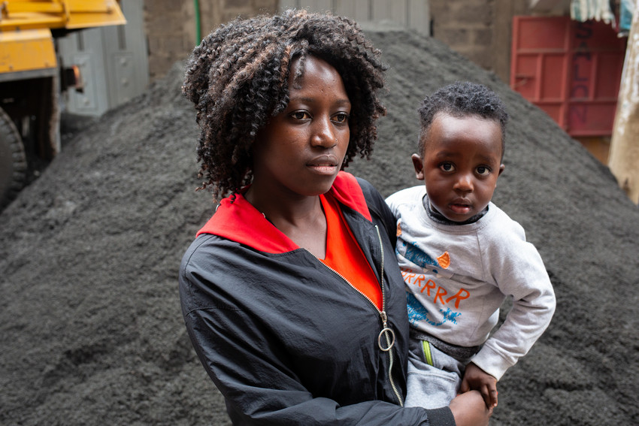
As Lutherans, our calling is a simple one: to love our neighbors. To learn more information about our partnership with Lutheran World Relief, visit lwr.org.

Lilian and her son Nevil live in a slum in Nairobi, Kenya. Though they have love in their home, they do not have clean water. But our congregation’s partnership with Lutheran World Relief can make the difference.

<BULLETIN UPDATE>

Through Lutheran World Relief, our congregation’s love can reach anywhere.
Lilian Mutheu grew up one of the largest slums in Nairobi, Kenya. The streets are littered with trash and waste, and communicable diseases like COVID-19 spread quickly due to cramped conditions and a lack of clean water and sanitation. Lilian works hard with the hope of giving her four-year-old son everything she didn’t have in life — opportunity, unconditional love, a safe place to call home. She has even become a mentor to other young girls, offering advice and support to help them make healthy choices. But, despite her efforts and hard work, Lilian and Nevil still live in the slum. And though they have love, they do not have clean water at home. Safe water is the most expensive item families in Mukuru have to buy, and many are forced to choose between essentials: food, water, soap, rent, medical care. It’s a choice no mother should have to make. One way our congregation can make a difference today is with the gift of clean water so families can save money, cook and drink safely, wash their hands and avoid getting sick and even dying from waterborne illnesses. To learn more about our partnership with Lutheran World Relief, see this month’s newsletter article and visit lwr.org.

<SOCIAL MEDIA UPDATE>

Share this social media update on your congregation’s Facebook page. The photos included below can all be downloaded at this link. Please do not copy the photos directly from this document.

To share this update:
- Download the images below using this link. Please do not copy and save the photos directly from this document.
- Create a new post on your congregation’s Facebook page.
- Copy and paste the bold text below into the status message.
- Add the photos you downloaded to your post.
- Hover over the photos with your mouse and click on Edit All. Copy and paste the photo descriptions (below, to right of photos) in each photo caption box.
- Click on Done.
- Click on Post.

Though Lilian and her son Nevil have love in their home, they do not have clean water. But our congregation’s partnership with Lutheran World Relief can make the difference.

Lilian Mutheu and her son Nevil live in Mukuru, one of the largest slums in Nairobi, Kenya.

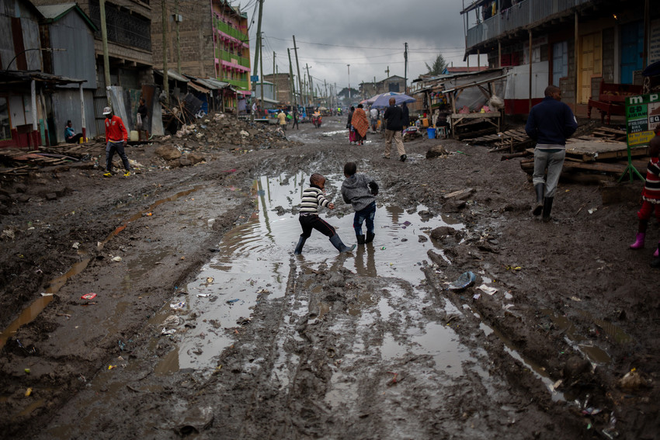
The living conditions in Mukuru are some of the worst imaginable. The streets are littered with trash and waste, and communicable diseases like COVID-19 spread quickly due to cramped conditions and a lack of clean water and sanitation.

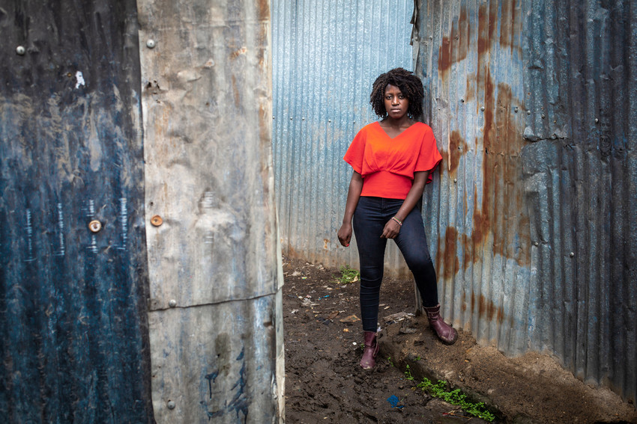
Lilian was a bright girl, studied hard and got a job, but she ran into challenge after challenge. The men at work sexually harassed her and soon her mother began demanding all of Lilian’s wages. When Lilian wouldn’t comply, her mother threw her onto the street and before long, Lilian became pregnant.

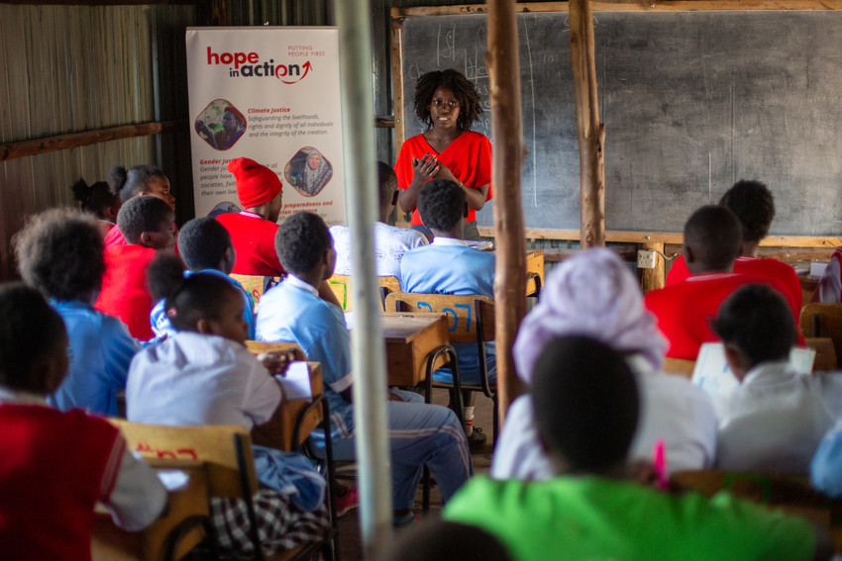
Lilian continues to work hard with the hope of giving her son everything she didn’t have in life — opportunity, unconditional love, a safe place to call home. She has even become a mentor to other young girls, offering advice and support to help them make healthy choices.

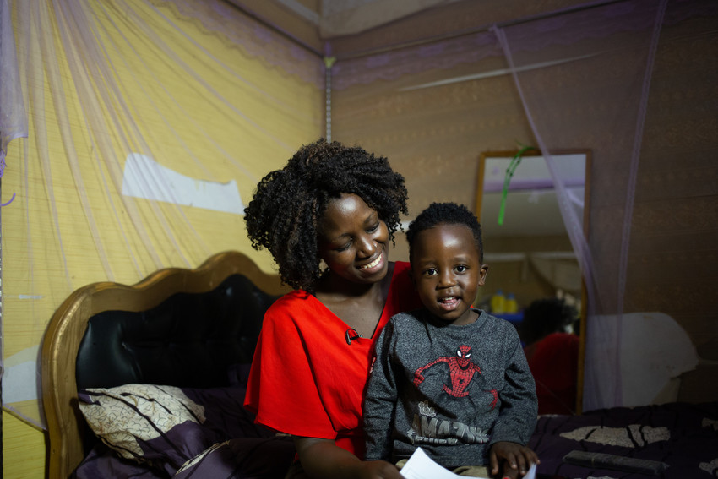
But, despite her efforts and hard work, Lilian and Nevil still live in the slum. Safe water is the most expensive item families in Mukuru have to buy, and many like Lilian are forced to choose between essentials: food, water, soap, rent, medical care. Through Lutheran World Relief, our love can reach anywhere — even into the slums Lilian calls home. To learn more about our partnership, visit lwr.org.

TO DOWNLOAD AND SHARE THESE PHOTOS OF LILIAN AND NEVIL, VISIT:
https://photos.lwr.org/?c=2984&k=d00848cc3f

<VIDEO ENGAGEMENT>

Lilian’s story is a powerful one that demonstrates the importance of Lutheran World Relief’s partnership with organizations like IMA World Health and other faith-based organizations. For a deeper dive into exploring what life is like for Lilian and the nearly 50% of Kenyan women aged 15 to 49 who have experienced gender-based violence, watch and discuss this video with your congregation.

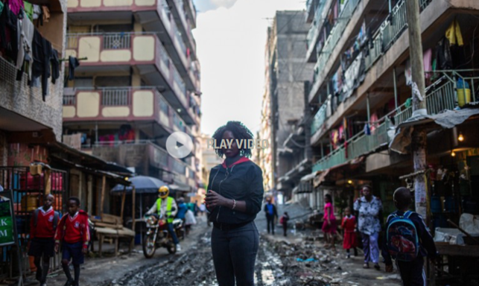

TO VIEW THIS VIDEO, VISIT
http://www.apmultimedianewsroom.com/multimedia-newsroom/faith-groups-battle-for-sexual-health-and-rights

