Congregational Update
Summer 2020
Rajendra

Dear Partner in Ministry,

Thank you for your congregation’s partnership with Lutheran World Relief. Your love is making a powerful difference around the world in the lives of our neighbors.

This document includes updates for you to share with your congregation in a variety of ways: newsletter article, bulletin announcement, social media kit and video. It is formatted so that your staff or volunteers can copy and paste the text directly into your congregation’s publications.

To share the photos that accompany this update, please use the link at the end of the document to access and download the images. Please do not copy the photos directly from this document.

Thank you for sharing this story with your congregation about the ways your generosity is reaching our neighbors around the world. We are deeply grateful for your partnership.

Please contact me if I can be of any assistance.

Rev. Lisa Kipp
Senior Manager, Congregations
lkipp@lwr.org
612-248-2219

<NEWSLETTER UPDATE>

Our love can rise above the floodwaters and COVID-19 in India and Nepal through Lutheran World Relief

Rajendra Kushwaha and Nikky Devi woke up to find water pouring into their bamboo and mud home. They did what they always do when the river floods its banks: they grabbed their young daughters and ran.

In the darkness, Rajendra and Nikky struggled to carry their children through the water as debris slammed into their legs. When they finally made it to higher ground, their neighbors’ cries told them that others were not as lucky.

The river, which creates a natural border between India and Nepal, makes the land fertile for growing crops. But when the water rises, as it often does, it is devastating for the families who can’t afford to live anywhere except the floodplains.

Floods frequently wash away their wheat and rice fields and drown their livestock. Afterward, hunger and illness loom. Right now, COVID-19 cases are rising, and the pandemic lockdown has made it hard to purchase seeds. Without time to get seeds in the ground before the monsoons hit, widespread hunger is feared.

But our congregation’s love can overcome even the highest waters to reach neighbors like Rajendra and Nikky in their time of need.

For them, our love sounds like an announcement made through a megaphone, letting them know a flood is coming. This early warning system urges their entire village to evacuate well before the floodwaters arrive. Our love can teach them new farming techniques — like growing food on rooftops or in hanging baskets — so their vital crops don’t wash away. Our love can share information about how they can stop the spread of coronavirus.

The need is urgent; they have so little left to lose. Thank you for putting faith into action and loving these neighbors generously. Together we proclaim that nothing — not floodwaters or hunger or poverty — can separate us from the love of God.

Lutheran World Relief won’t stop until our love reaches every neighbor. To learn more information about our partnership with Lutheran World Relief, visit lwr.org.

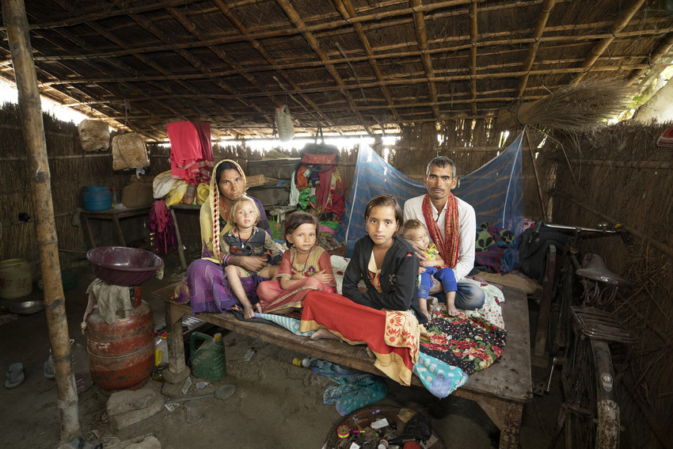
Floods frequently wash away Rajendra’s crops and livestock. But our congregation’s love in partnership with Lutheran World Relief can overcome even the highest waters to reach neighbors like Rajendra, Nikky and their daughters in their time of need.

<BULLETIN UPDATE>

Our love can rise above the floodwaters and COVID-19 in India and Nepal through Lutheran World Relief.
Rajendra Kushwaha and Nikky Devi woke up to find water pouring into their bamboo and mud home. In the darkness, they struggled to carry their children through the water. When they finally made it to higher ground, their neighbors’ cries told them that others were not as lucky. Flooding is common where they live, and when the waters come they destroy the family’s crops and livestock without warning. And right now, COVID-19 cases are rising, and the pandemic lockdown has made it hard to purchase seeds. Without time to get seeds in the ground before the monsoons hit, widespread hunger is feared. Rajendra and Nikky are trapped in a vicious cycle of poverty and disaster. But our congregation’s love can overcome even the highest waters to reach neighbors like Rajendra and Nikky in their time of need. To learn more information about our partnership with Lutheran World Relief, see this month’s newsletter article and visit lwr.org.

<SOCIAL MEDIA UPDATE>

Share this social media update on your congregation’s Facebook page. The photos included below can all be downloaded at this link. Please do not copy the photos directly from this document.

To share this update:
- Download the images below using this link. Please do not copy and save the photos directly from this document.
- Create a new post on your congregation’s Facebook page.
- Copy and paste the bold text below into the status message.
- Add the photos you downloaded to your post.
- Hover over the photos with your mouse and click on Edit All. Copy and paste the photo descriptions (below, to right of photos) in each photo caption box.
- Click on Done.
- Click on Post.

Our congregation’s love is rising above the floodwaters and COVID-19 in India and Nepal through Lutheran World Relief.

Rajendra Kushwaha and Nikki Devy live on the Gandak river basin along the border of India and Nepal. When water started pouring through their bamboo and mud home, they did what they always do when the river floods its banks: they grabbed their young daughters and ran.

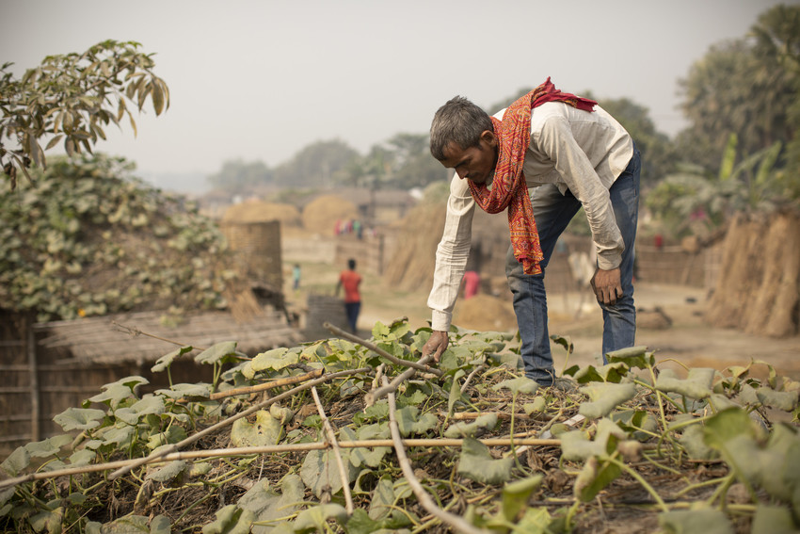
Thanks to our congregation’s love and partnership with Lutheran World Relief, Rajendra’s family has learned new farming techniques – like growing food on the rooftop – so their vital crops don’t wash away.

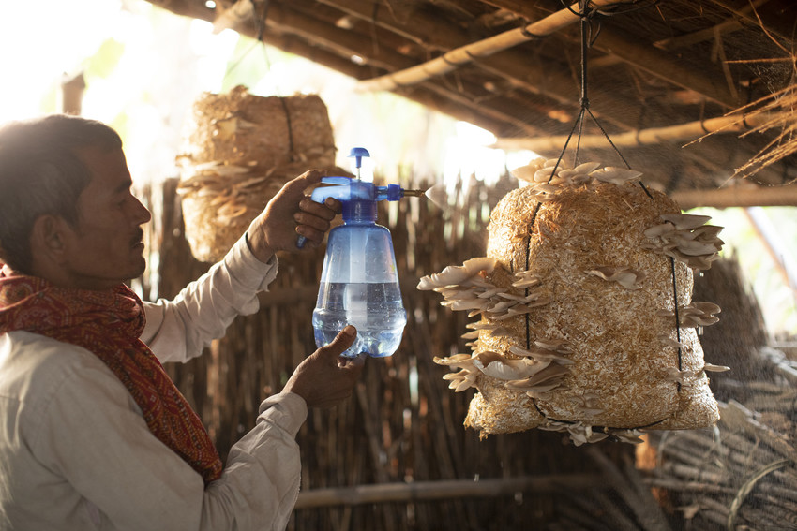
Rajendra and his neighbors have also learned how to farm using hanging baskets that can survive rushing flood waters. Our congregation’s love ensures that Rajendra’s daughters will have food to last them throughout the year.

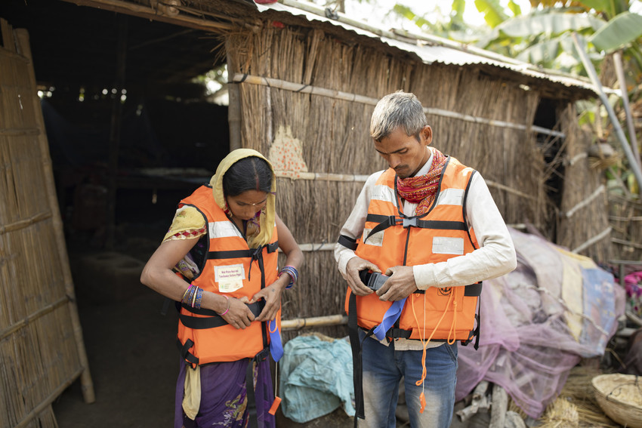
Lutheran World Relief has worked in villages all along the India and Nepal border to ensure that our love is reaching neighbors through early warning systems, emergency equipment and announcements about how they can stop the spread of coronavirus.

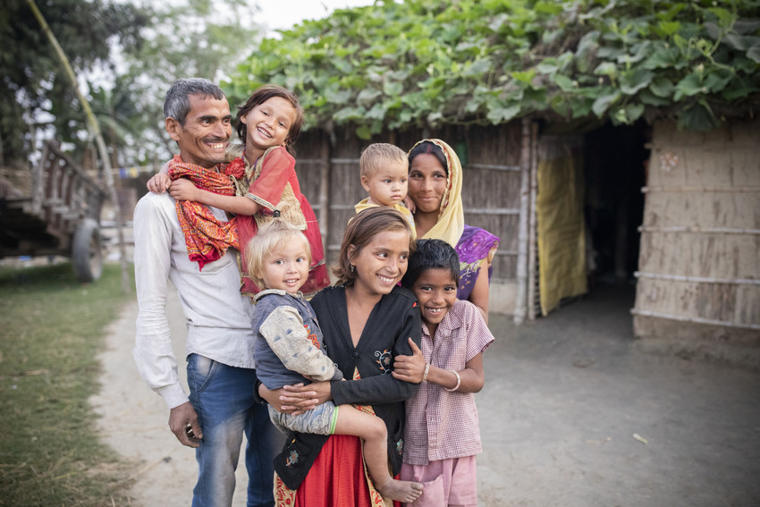
The need of our most vulnerable neighbors around the world is urgent. But when our congregation partners with Lutheran World Relief and puts faith into action, we proclaim that nothing – not floodwaters or hunger or poverty – can separate us from the love of God. To learn more about our partnership, visit lwr.org.

TO DOWNLOAD AND SHARE THESE PHOTOS OF RAJENDRA AND HIS FAMILY, VISIT:
https://photos.lwr.org/?c=2928&k=d0a1a06272

<VIDEO UPDATE>

Tell Rajendra’s story to your congregation in worship or online by sharing this video.

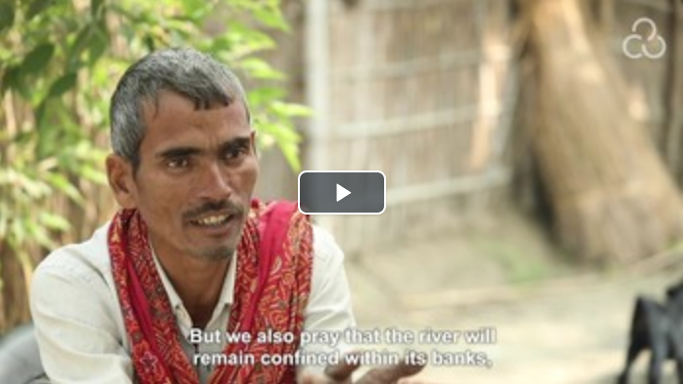

TO DOWNLOAD AND SHARE THIS VIDEO WITH YOUR CONGREGATION, VISIT:
https://photos.lwr.org/?r=27759&k=7275739a4f

