**Congregational Update**

**Fall 2022**

**Special Thank You: Ukraine**

Dear Partner in Ministry,

Thank you for your congregation’s partnership with Lutheran World Relief. Your love is making a powerful difference in the lives of our neighbors impacted by the tragic violence in Ukraine.

**This document includes updates for you to share with your congregation in a variety of ways: newsletter article, bulletin announcement, social media kit, photos and video.** It is formatted so that you, your staff or volunteers can copy and paste the text directly into your congregation’s publications.

To share the photos that accompany this update, [**use this link to access and download the images**](https://photos.lwr.org/?c=3665&k=525bd86cdc). Please do not copy the photos directly from this document.

**Thank you for sharing this story with your congregation about the ways your generosity is reaching our Ukrainian neighbors. We are deeply grateful for your partnership.**

Please contact me if I can be of any assistance.



Rev. Lisa Kipp

Director of Congregational Engagement

lkipp@lwr.org

**We joined Lutheran World Relief to help our Ukrainian neighbors in need.**

**NEWSLETTER UPDATE**

*Copy/paste this text into your congregation’s newsletter*

Our congregation has shown up for our neighbors who are suffering in abundant and overwhelming ways. We saw our Ukrainian neighbors fleeing in the harsh winter cold, children and belongings in tow, and our love welcomed them with quilts and kits. We saw refugees separated from loved ones, in strange new countries, and our generosity provided them with emergency supplies and support to rebuild their lives after destruction.

**Through your generosity, our congregation has become a part of something much bigger than ourselves.**

Our gifts shared through Lutheran World Relief have meant that families fleeing war have:

* **LWR Quilts and Care Kits.** We’ve helped ship nearly $1 million worth of LWR Quilts and Care Kits to provide comfort to neighbors in Ukraine and Poland.
* **Shelter and community.** More than 15,000 of the most vulnerable people who fled for safety within Ukraine have a safe place to stay because of our support.
* **Access to cash to support their children.** Ukrainians who have fled to Poland have received emergency cash vouchers to help with rent, health care and other necessities.
* **Life-saving medical care and supplies.** In addition to providing desperately needed care and supplies, our congregation is helping to send medical teams to areas where there is a critical shortage of health care.
* **Mental health resources.** War and conflict can have devastating impacts on not only the physical health of those in the crossfire but can also have long lasting mental health impacts. Our congregation is helping to provide resources to support these often-hidden wounds of war.

**And most importantly, because of our congregation, families fleeing war have hope.**

Our love is making a powerful difference around the world in the lives of our Ukrainian neighbors. **Thank you for sharing God’s love when it was needed most.**

To learn more about the work of Lutheran World Relief, visit lwr.org.

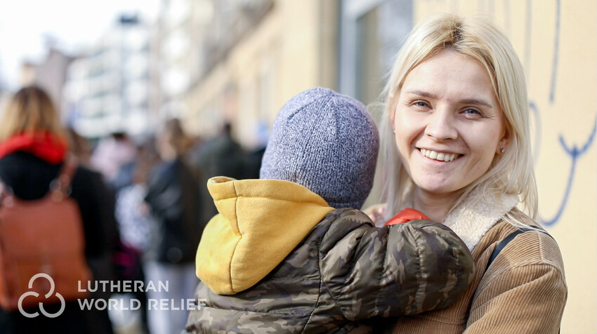In Krakow, Poland, newly arrived Ukrainian refugee Marta Detsyk and her four-year-old son wait in a line at a supplies distribution center. Because of our congregation’s support, refugees like Marta were welcomed with love following harrowing journeys from violence in Ukraine, receiving shelter, warm meals, medical care, emergency funds, quilts and other necessities.



**We joined Lutheran World Relief to help our Ukrainian neighbors in need.**

**BULLETIN UPDATE**

*Copy/paste this text into your congregation’s bulletin*

After millions were forced to flee violence following the invasion of Ukraine, our congregation responded with love. Through your generosity, our congregation became a part of something much bigger than ourselves. The gifts shared through Lutheran World Relief have provided shelter and community, warm meals, emergency cash funds, life-saving medical care and supplies, and mental health resources to the most vulnerable of our Ukrainian neighbors. But most importantly, because of our congregation, families fleeing war have hope. Our congregation’s love is making a powerful difference around the world in the lives of our Ukrainian neighbors. Thank you for sharing God’s love when it was needed most. To learn more about the work of Lutheran World Relief, visit lwr.org.

****Share this social media update on your congregation’s Facebook page. The photos included can all be downloaded at the link below. Please do not copy the photos directly from this document.

**SOCIAL MEDIA UPDATE**

*Copy/paste this text into your congregation’s Facebook page*

**To share this update:**

1. [Download the images below using this link.](https://photos.lwr.org/?c=3665&k=525bd86cdc) Please do not copy and save the photos directly from this document.
2. Create a new post on your congregation’s Facebook page.
3. Copy and paste the bold text below into the status message.
4. Add the photos you downloaded to your post.
5. Hover over the photos with your mouse and click on Edit All. Copy and paste the photo descriptions (below, to right of photos) in each photo caption box.
6. Click on Done.
7. Click on Post.

**Through your generosity, our congregation became a part of something much bigger than ourselves when we joined Lutheran World Relief to help our Ukrainian neighbors in need. Take a look at how our congregation’s love offered hope to families fleeing war.**

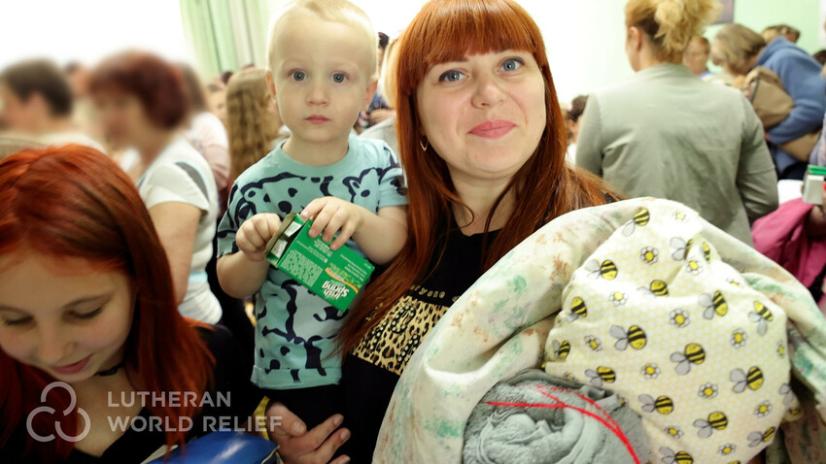We helped ship nearly $1 million worth of LWR Quilts and Care Kits to provide comfort to neighbors in Ukraine and Poland.

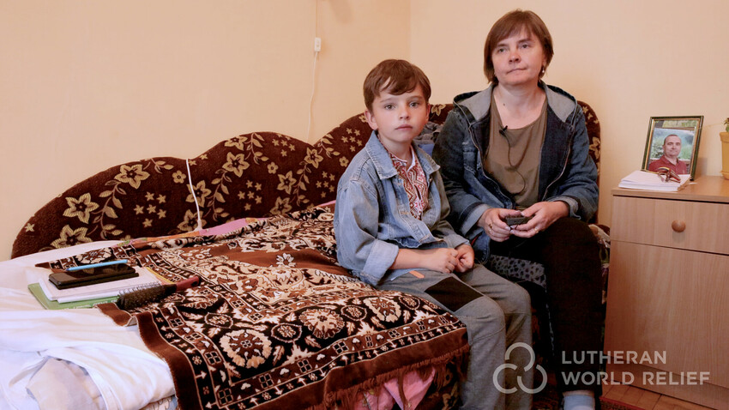Our love provided shelter and community. More than 15,000 of the most vulnerable people who fled for safety within Ukraine have a safe place to stay because of our support.

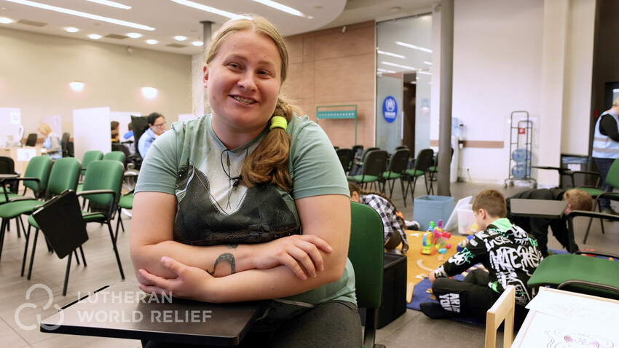We provided refugees access to cash to support their children. Ukrainians who have fled to Poland have received emergency cash vouchers to help with rent, health care and other necessities.

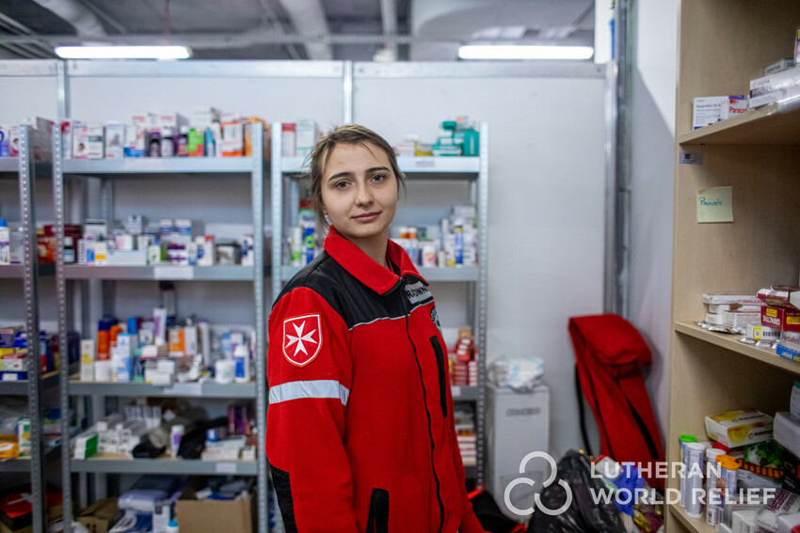Our love is delivering life-saving medical care and supplies**.** In addition to providing this desperately needed care and supplies, our congregation is also helping to send medical teams to areas where there is a critical shortage of health care.

Thank you for sharing God’s love when it was needed most. To learn more about Lutheran World Relief, visit lwr.org.

**TO DOWNLOAD AND SHARE THESE PHOTOS, VISIT:**

[**https://photos.lwr.org/?c=3665&k=525bd86cdc**](https://photos.lwr.org/?c=3665&k=525bd86cdc)

**VIDEO TO SHARE**

*Share this video in worship or on your congregation’s Facebook page*

[](https://youtu.be/6HVgVMqI1O4)

Please share this thank you video with your congregation in worship or online.

**Short version (2:43)**

View and share on YouTube: <https://youtu.be/6HVgVMqI1O4>

Download and share: <https://photos.lwr.org/?r=40674&k=4629b2d628>

**Long version (5:19)**

View and share on YouTube: <https://youtu.be/sXwIyYfU3oQ>

Download and share:<https://photos.lwr.org/?r=40673&k=a36a4f1e8c>