
Emergency Response!
Haiti Earthquake
2021

Dear Partner in Ministry,

Thank you for your congregation’s partnership with Lutheran World Relief. Your love is making a powerful difference around the world in the lives of our neighbors.

This document includes updates for you to share with your congregation in a variety of ways: bulletin or newsletter announcement, social media update, worship slides, and photo album. It is formatted so that you, your staff or volunteers can copy and paste the text directly into your congregation’s publications.

To share the photos that accompany this update, please use the link at the end of the document to access and download the images. Please do not copy the photos directly from this document.

Thank you for sharing this emergency appeal with your congregation. We are deeply grateful for your partnership.

Please contact me if I can be of any assistance.



Rev. Lisa Kipp
Senior Manager of Congregational Engagement
lkipp@lwr.org
410-230-2857

P.S. Gifts can be made online at www.lwr.org/GiveHaiti.

Or if you prefer, checks can be mailed to:
Lutheran World Relief
PO Box 17061
Baltimore, MD 21297

Please write Haiti in the memo.

Our neighbors in Haiti urgently need our congregation’s love.

BULLETIN OR NEWSLETTER ANNOUNCEMENT
Copy/paste this text into your congregation’s bulletin or newsletter

A devastating 7.2 magnitude earthquake struck our neighbors in Haiti on August 14 – a brutal blow to this impoverished country still recovering from the disastrous 2010 quake and fighting a surge of coronavirus infections. Within days, Tropical Storm Grace battered children, women, men and seniors struggling to survive outside or in flimsy, makeshift shelters. The death toll has climbed to over 2,100 people with more than 12,000 injured. Tens of thousands of families are homeless. Churches, schools, health care clinics and hospitals have collapsed. The risk of cholera and other illnesses spreading quickly due to contaminated water is extremely high, as is the spread of COVID-19 with people cramped so closely together.

Our partners from Lutheran World Relief are on the ground in Haiti right now assessing needs and sharing the love of U.S. Lutherans. Our congregation can help. Your emergency gift will provide neighbors in Haiti with emergency food, clean water and lifesaving medical care. You’ll also help distribute urgently needed medical supplies, hygiene kits, tarps for emergency shelters, and other vital disaster relief provisions.

Please give now at www.lwr.org/GiveHaiti. [or insert your congregation’s giving instructions]

TO DOWNLOAD AND SHARE PHOTOS WITH THIS ANNOUNCEMENT, VISIT:
https://photos.lwr.org/pages/search.php?search=%21collection3376&k=6a16f054eb


Share this social media update on your congregation’s Facebook page. The photos included can all be downloaded at the link below. Please do not copy the photos directly from this document.
SOCIAL MEDIA UPDATE
Copy/paste this text into your congregation’s Facebook page

To share this update:
- Download the images below using this link. Please do not copy and save the photos directly from this document.
- Create a new post on your congregation’s Facebook page.
- Copy and paste the bold, blue text below into the status message.
- Add the photos you downloaded to your post.
- Hover over the photos with your mouse and click on Edit All. Copy and paste the photo descriptions (below, to right of photos) in each photo caption box.
- Click on Done.
- Click on Post.

Our neighbors in Haiti urgently need our congregation’s love.

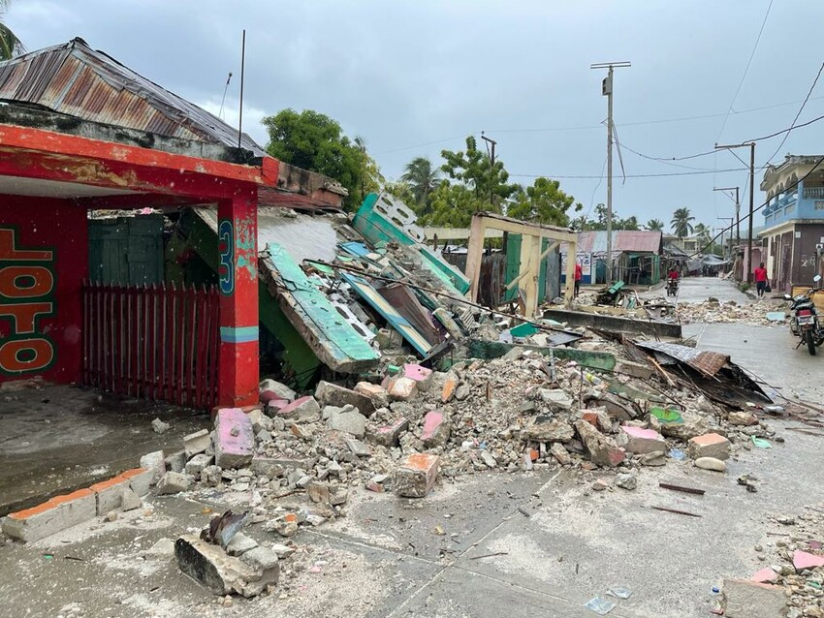
A devastating 7.2 magnitude earthquake struck our neighbors in Haiti on August 14 – a brutal blow to this impoverished country still recovering from the disastrous 2010 quake and fighting a surge of coronavirus infections. Roads are inaccessible throughout many regions of the country.

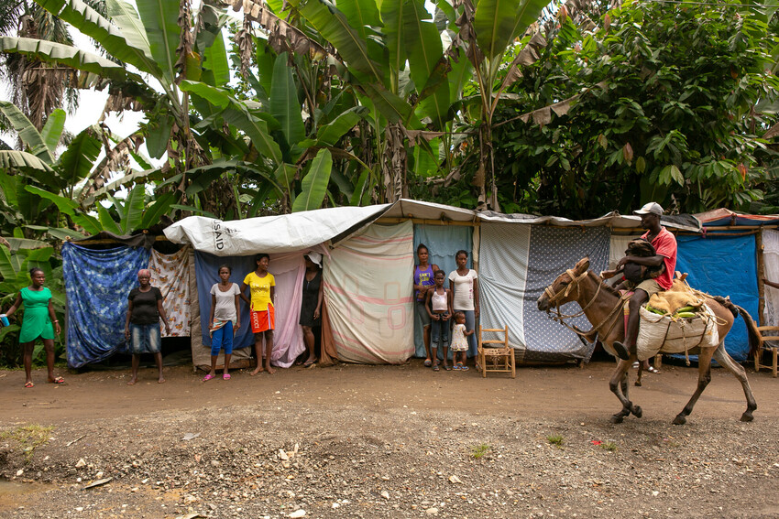
Families stand in front of their makeshift dwellings, tent-sized shelters made of tarps and wood, along the side of the road near Chambellan, in the Grand’Anse department of Haiti, one week after the earthquake that destroyed their homes.

Onella Michel, 6, stands in the ruins of her school in Chamberllan, Haiti, one week after the 7.2 earthquake that devasted much of the region. “I was trembling,” said Onella of that day. She escaped harm by the quick action of her mother, who grabbed her hand and ran her to the street as soon as the shaking began.

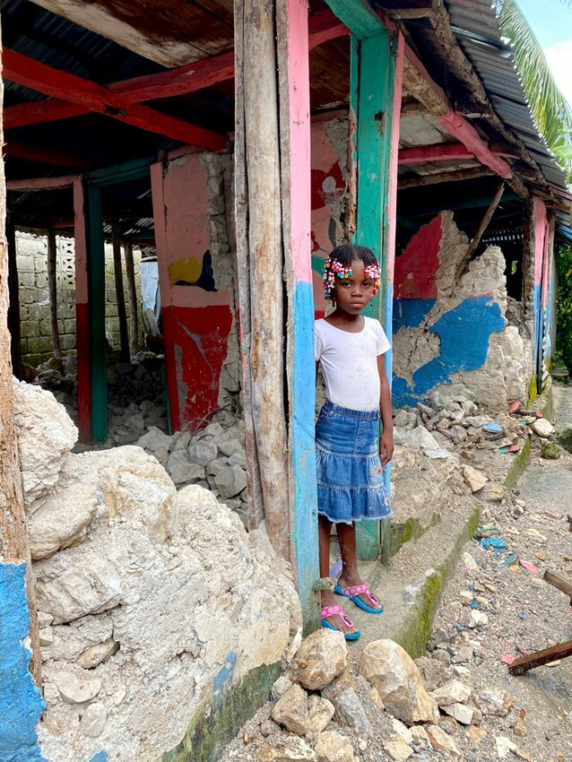

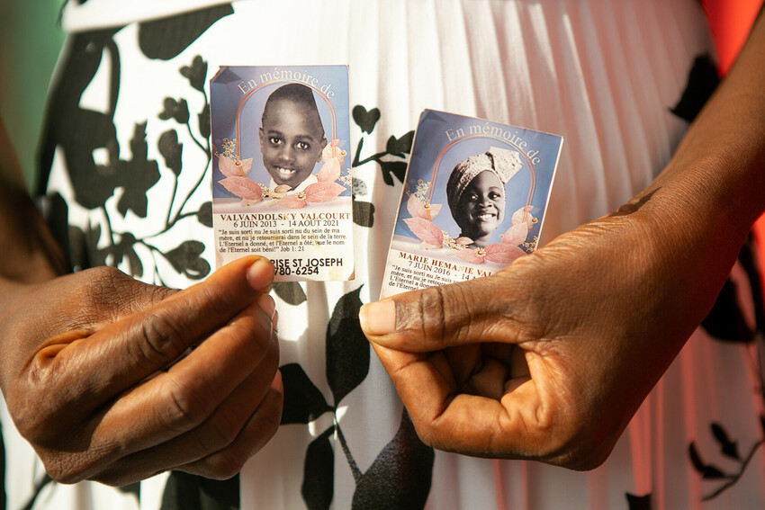
Marie Entonnance Dely, 45, holds photos of her nephew Valvandolsky Valcourt, 8 and Marie Hemanie Valcourt, 5, who were killed when their home in downtown Jeremie, Haiti collapsed in the August 14 earthquake. The two had been playing video games on the couch. Dely says that it took over three hours to dig them out and that passersby were more interested in looting the grocery depot next door than helping.

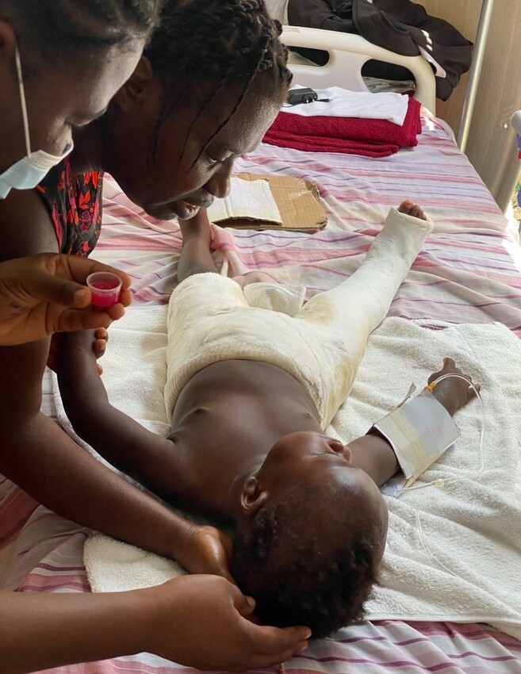
Islande Joseph helps a nurse administer medication to her son Evenson Dorvil, 22 months, at St. Antoine Hospital in Jeremie, Haiti. Evenson suffered extensive injuries, including a complete fracture to his right leg, when a wall of the family home fell on him during the earthquake. The house was totally destroyed.

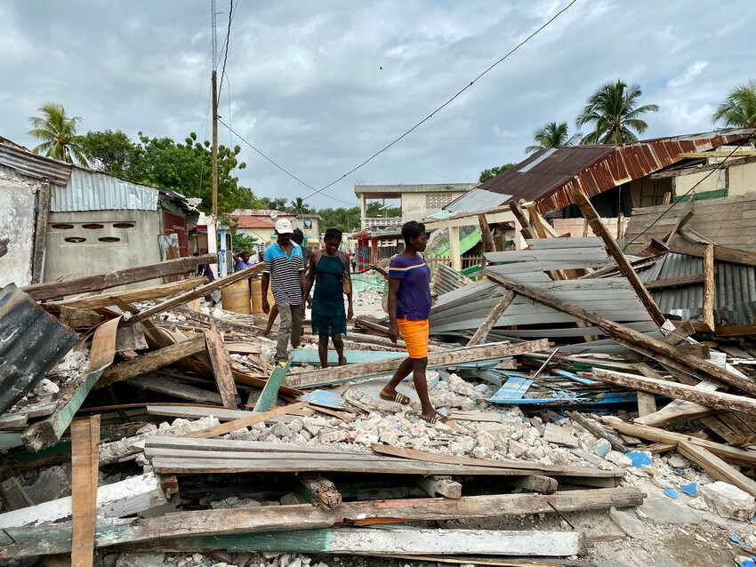
Your love can make a difference and bring hope to our most vulnerable neighbors. Please make a gift today at www.lwr.org/GiveHaiti and let our must vulnerable neighbors know that Lutherans in the United States care for them.

TO DOWNLOAD AND SHARE THESE PHOTOS, VISIT:
https://photos.lwr.org/pages/search.php?search=%21collection3376&k=6a16f054eb

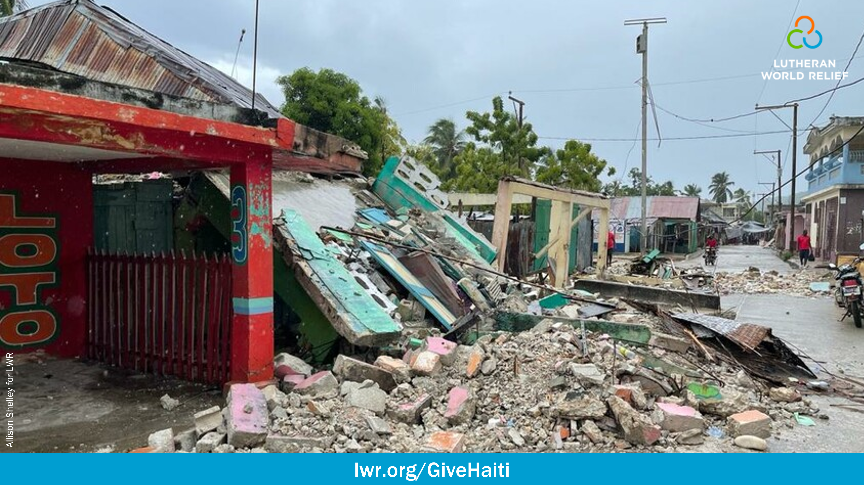

WORSHIP SLIDES
Share this PowerPoint in worship

Please download and use this PowerPoint as part of your congregation’s worship. The slides include images and stories (available in the notes section) that show the devastating conditions and suffering our neighbors are experiencing in Haiti.

TO DOWNLOAD THIS POWERPOINT, VISIT:
https://lwr.org/downloads/haiti-emergency-response-worship-announcement

PHOTO ALBUM
Download and share these images with your congregation

TO DOWNLOAD AND SHARE ANY OF THE PHOTOS IN THIS DOCUMENT, VISIT:
https://photos.lwr.org/pages/search.php?search=%21collection3376&k=6a16f054eb

